**MAJOR PROJECT REPORT**

## SYSTEM DEBUGGER

B.Tech in Computer Science &Engg.under Punjab Technical University , Jalandhar



Submitted by

**BrahmleenKaur**

**1188250**

Submitted To:

**Er.KalpnaVermaEr.AsishVerma**

**(Associate Prof & HOD CSE/IT) Asst. Prof. CSE**

# Department Of Computer Science Engineering

**RBCEBTW, SAHAURAN, KHARAR**

**2020**



COMPANY PROFILE

**1st Ranked in Training of software development**



 **U.K. INDIA U.S. KUWAIT UAE EGYPT TURKEY MANGOLIA THAILAND INDONESIA**

4

**ABOUT US**

**EXCELLENCE TECHNOLOGY (ET)** is India based leading strategic IT Company offering integrated IT solutions with the vision to provide Excellence in software solution. We at EXCELLENCE TECHNOLOGY bring innovative ideas and cutting edge technologies into business of customers. EXCELLENCE TECHNOLOGY is having rich experience in providing high technology end to end solutions in **MOBILE APP AND WEB DEVELOPMENT.**

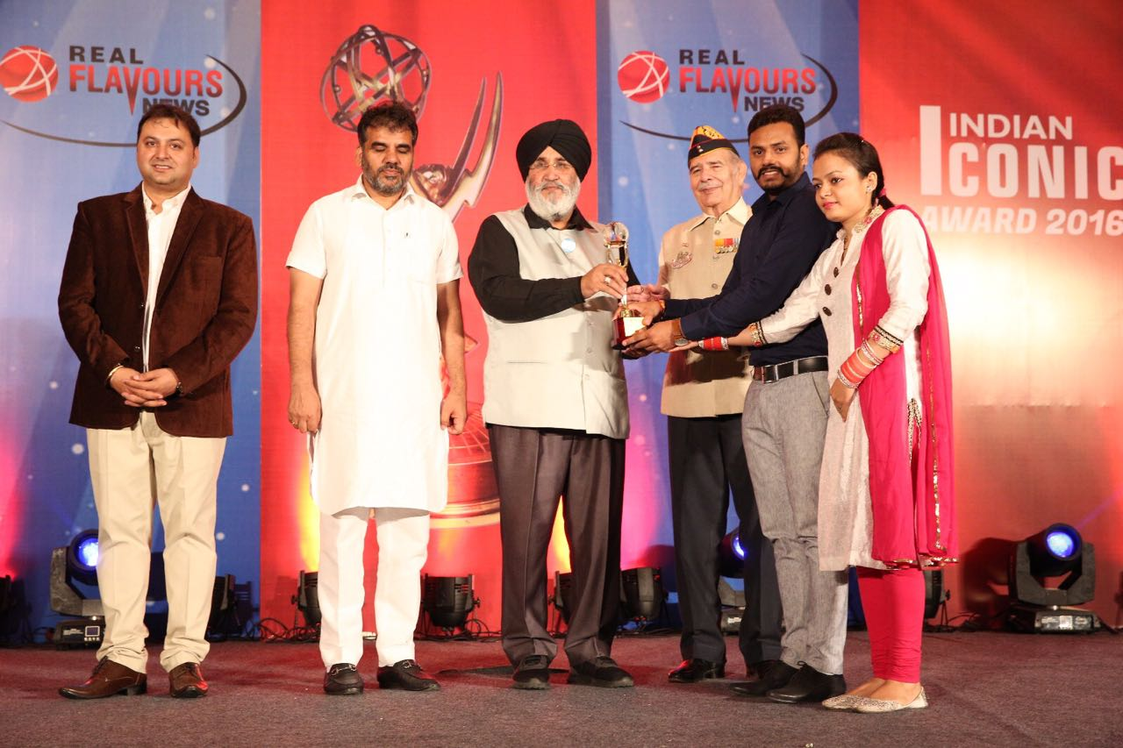**EXCELLENCE TECHNOLOGY** managing global clients across various business verticals and align IT strategies to achieve business goals. The various accreditations that we achieved for every service, we offer reflect our commitment towards the quality assurance. **ET** has won the **NATIONAL AWARD** for**2015-16** for the highly appreciable contribution in the field of computersfrom**Hon’able Education Minister Of Punjab Dr.Daljit Singh Cheema**

**Excellence Technology Receiving National Award from**

**Hon’ableEx. Education Minister Of Punjab Dr.Daljit Singh Cheema**

We feel pleasure to acquaint with our company as a pioneer in the field of Software Development & Industrial Internship. Our Company involves in **Software Development**, **Web Designing, Industrial Training, Corporate Training, Consulting and Promoting outstanding products** of various companies. We have substantial experience in **Analyzing, Designing, Developing, Testing, Implementing and Supporting projects**. We have a global foot prints in providing the EXCELLENCE TECHNOLOGY companies of **US, UK, France, Ireland, Canada and Australia with quality and timely Web Development and SEO services**.

**OUR TEAM:**

The foundation upon which our team is created is based upon the premise that motivated people and long-standing relationships are the ultimate tools of success and creativity, energy, perseverance and loyalty are just as important as a platinum resume.

We have a team of highly qualified and experienced professionals with proven problem solving, consulting and analytical skills. Our Team consists of Domain Experts & Technical Specialists to provide world class Business development solutions to global clients.

**PHILOSOPHY**

* To impart hardcore practical quality training among students/developers about latest technologies trending today.
* To share knowledge of information security and create awareness in the market. The solution to clients' as per the International standard practices and governance.
* To support good business practices through continual employee training and education
* To equip a local team with a strong knowledge of international best practices and international expert support so as to provide practical advisories in the best interests of our clients

**VISION**



To be a Leading information risk assessors by protecting the client organization's information system from threats and vulnerabilities.

To achieve the development objective to the best established practices and recognized standards worldwide and Regulatory as well as statutory obligation of the region in which organization is operating.

**OUR MISSION**



To Protect Client's information system by

Detecting Threats, Deterring Attacks, and provide best solution in the ever changing Info-Security Challenges. We accomplish this by integrating our People, Process and Technology in the most efficient way to increase value for all stakeholders

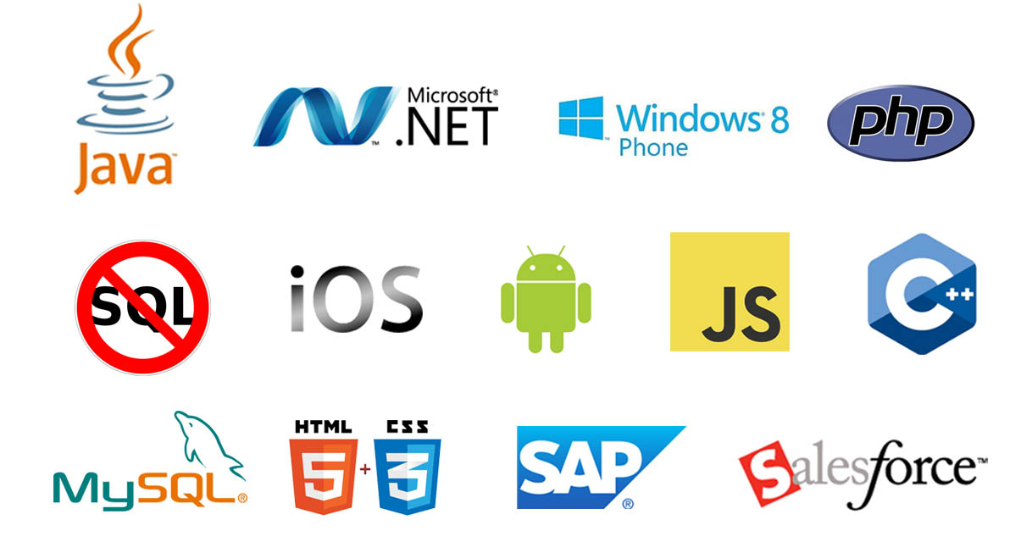

**OUR SERVICES**

* RISK Management Services
* Quality Control
* Business Process Re-Engineering
* Network Risk Analysis
* Software Testing
* Mobile Application Testing
* Wireless Penetration Testing
* Network Penetration Testing
* Application Security Testing

**OUR SERVICES IN SOFTWARE DEVELOPMENT**

***We are proficient in all platforms of software Development practices — Agile, SCRUM, Lean, Waterfall, Prototype, Incremental, Iterative, and V-Model.***

With the EXCELLENCE TECHNOLOGY experience the incredible services such as agile software development and the problems related to outsourcing. We comprise of the team of experienced and professionals members who with their skills efficiently get the job done and innovatively help you to transform your ideas into the successful business.

Why Choose Us?

* **Hundreds of Clients & Nearly a Decade of Experience**
* **Goal Oriented, ROI-Driven Focus**
* **A Streamlined / Quality-Driven Process**
* **Talented Designers & Expert Developers**
* **Our Websites & E-marketing Platforms are Easy to Manage**
* **We Are Dedicated to Our Clients’ Success**
* **EXCELLENCE TECHNOLOGY** is steadfast to undertake the projects cutting edge to technology competence and know-how abilities. The project execution is held with dedication and responsibility to perform our best with the essence of knowledge, creativity and skills to the utmost and efficiently.
* At **EXCELLENCE TECHNOLOGY,** we have competence to expand and adjust as per client specific requirements.
* **Skilled Workforce:** At EXCELLENCE TECHNOLOGY you deal with the highly professional and proficient employees.
* **Cost Efficiency:** We help you to reduce the unnecessary investment and ask for the reasonable amount of money.
* **Quality Of the Product:** Our software service sector has been maintaining the highest international standards of quality.
* **Infrastructure:** Well organized team and tools to handle the projects with responsible approach Hardware, Software, Networking, Voice, Conferencing, disaster recovery all infra all you need for international projects.
* **Ongoing Involvement:** EXCELLENCE TECHNOLOGY products are “built for change” as we are well responsive that the necessity to improve a Web solution generally arises even before the solution is out of the door. We delivers long-term product enhancement if desired.
* **Partnership:** EXCELLENCE TECHNOLOGY considers every client a partner. From the initial stages, you are closely involved into the procedure of technical classification, development, and testing.

**OUR CLIENTS**



**KEY PROFESSIONALS:**

In addition to a panel of eminent consultants and advisors, we have a dedicated pool of trained Developers and Trainer, investigators, working under the guidance of professional managers. **“A Ship is as good as the crew who sail her**.**”**Our Technical team of professionals handing, designing & delivering of projects has a strong presence in the North India & the US. Our engineers are already working on the latest technologies like **I-Phone & Android** Applications, **Robotics**, **VLSI-VHDL**, Embedded System, Networking and **Cloud computing.** And other fields like **Finance HR and Business Department** we are providing services. Some of the key professionals and advisors are listed below:

**Mr. Deepak Kashyap:**(**Branch Manager**)

He is the backbone of Excellence Technology and a man with more than 10 year rich practical experience who believes in taking up new ventures and projects Head-IT, Global Award Winner from India for AGILE and OPEN GRAPH implementation in **Sudan Taxation Chamber**. Divisional Award and Star Award Winner in Year 2011 for his exemplary work in process improvement for IT Service Delivery Domains MASTERS in Computer applications and Certified from PTU Certification Holds total of 10 Years of rich experience including 5 Years in Information Security Implementation, Maintenance and Auditing and initial over 10 years experience in Project Management, Client Relationship Management and Server, Desktop and IT Service Delivery.

**Ms. Sunita Thakur :**(**Dean Academics**)

A Woman who believes that “Honors Time & Place, then you will be honored” She has more than 4 years solid industrial experience in a software companies & is very dashing and innovative in her technical approach.MCA, Diploma in Information Technology, expertise in search engine optimization and web designing.

**Mr. Gurpreet Singh :(Technical Head - Python & GIT HUB)**

A man who strongly feel that “Nothing is Impossible”. A very committed team leader who has been professionally attached with Multinational companies for more than 18 years and has lead the marketing teams in all states of North India.MCA (Engineering),in computer Science PTU Approved trained and Certified. Successfully MCA master degree Training program for a leading Technology. Holds total of 5 Years of rich experience including 3 Years in Software developer, Maintenance and Auditing and initial over 4 years experience in Project Management, Client Relationship Management and IT Service Delivery.

**Miss. Anjali Sharma:(Sr. Counselor)**

A woman who believes that “Challenges are what make life interesting and overcoming them is what makes life meaningful.” She has more than 3years experience in study, development. M.C.A. – (H.P.T.U) Lead Consultant - Due Diligence, Strategy, Operations, Business Continuity, Risk Management, Mergers & Acquisitions.

**Mr. Rajat Kumar: (Mechanical Head)**

A man believes those “don’t wait for extra ordinary opportunities, seize common occasions and make them great.” He has more than 4 years experience in marketing field B.Tech (Mech), Engineer and Value, is a approved by AICTE (HPTU). He is having total 5 years of experience in 3 years of experience in AutoCAD, Solid works, Catia, Pro-e, Ansys etc.

**Mr. Paramveer Singh :( Mobile Application & Web Developer)**

B.Tech (CSE) – IKG-PTU, Expertise in Reviewing current systems, Presenting ideas for web development software’s, including Application software’s, Working closely with analysts, Senior Developers, Programmers, designers and staff, Producing detailed specifications and writing the program codes, Testing the product in controlled, real situations before going live, Preparation of training manuals for users and Maintaining the systems once they are up and running

**Corporate Office:** Plot No.- C-133,First Floor,

Near PCL Chowk, Phase 8, Sector 72, Mohali.

**PH.**:0172-4788822, 93177-88822, 93562-55522

**E-MAIL**: excellencehead@gmail.com,

**URL:**www.excellencetechnology.in

**CONTENTS**

|  |  |  |
| --- | --- | --- |
| **Contents** |  | **Page No.** |
|  | Declaration……………………………………………………….. | (i) |
|  | Abstract…………………………………………………………... | (ii) |
|  | Acknowledgement………………………………………………... | (iii) |
|  | List Of Figures…………………………………………………… | (iv) |
|  | Chapter 1: Introduction Of Project……………………...……….. | 1 |
|  | Chapter 2: Literature Review................…………………..……… | 4 |
|  | Chapter 3: Problem Formulation And Methodology …………….  A) Problem Formulation-  B) Research Objectives  C) Work Done  D) Proposed Work  E) Overview Of Methodology | 7 |
|  | Chapter 4: Implementation ………………………………………  A) DFD  B) ER diagram  C) UML diagram | 13 |
|  | Chapter 5: Results And Discussion………………….……………  A) Database Tables  B) Snapshots | 25 |
|  | Chapter 6: Conclusion & Future Scope …………………………. | 53 |
|  | References………………………………………………………... | 55 |

**DECLARATION**

I hereby declare that the project work entitled **“SYSTEM DEBBUGER”** is an authentic record of my own work carried out at (RBCEBTW) as requirement of six months training for the award of degree of B.E. (Computer Science Engineering), RBCEBTW, during _________ to _________

(Signature of student) BrahmleenKaur – 1188250

Date: ___________________

**ABSTRACT**

The System Debugger is introduced to develop hardware fault detection for any computer system. Different hardware system or electronics devices usually face application fault as well as hardware fault. This application oriented formal reasoning applies to determine the problem in computer system. This paper emphasizes an automated system that accepts the defects of any system and then after consulting with an intelligent database, diagnoses and advises for probable rectification. This paper extends that concept exploring the boundary of Expert System targeting the implementation using Object Oriented web based programming approach. It proposes lot of new technological changes and inclusion to make the system more perfective and efficient data handler.

**ACKNOWLEDGEMENT**

First of all I would like to thank the Almighty, who has always guided me to work on the right path of the life. I acknowledge with deep sense of gratitude and most sincere appreciation, the valuable guidance and unfailing encouragement rendered to me by *“NAME OF THE GUIDE” “DESGNATION*” for their proficient and enthusiastic guidance, useful encouragement and immense help. I have been deep sense of admiration for them inmate goodness and inexhaustible enthusiasm.

I wish to extend my sincere gratitude to “*Er. KalpnaVerma Associate.Prof. and HOD of CSE/ IT and ErAshishVermaAsst. Prof of CSE Department”* for their guidance, encouragement and valuable suggestions which proved extremely useful and helpful in completion of this industrial training.

My heartfelt gratitude and indebtness goes to all teachers and guidance group who with their encouraging, caring words, constructive criticism and segmentation have contributed directly or indirectly in a significant way towards completion of this training. My special thanks go to my friends whose support and encouragement have been a constant source of assurance, guidance, strength, and inspection to me.

I am immensely grateful to my parents, my family. They have always supported me and taught me the things that matter most in life. I am proudly grateful to all of them.

Date:

BrahmleenKaur – 1188250

**LIST OF FIGURES**

|  |  |  |
| --- | --- | --- |
| **Fig. No.** | **Figure Name** | **Page. No.** |
| 1.1 | Different Problem Modules Of Computer Hardware Faults | 3 |
| 4.1 | Level 0 DFD | 16 |
| 4.2 | Level 1 DFD | 16 |
| 4.3 | Level 2 DFD | 17 |
| 4.4 | ER Diagram | 18 |
| 4.5 | Use Case Diagram | 20 |
| 4.6 | Sequence Diagram | 21 |
| 4.7 | Collaboration Diagram | 22 |
| 4.8 | State Diagram | 23 |
| 4.9 | Class Diagram | 24 |
| 5.1 | Database Table | 25 |
| 5.2 | Desktop Table Entries | 26 |
| 5.3 | Desktop Table Entries_Cont. | 27 |
| 5.4 | Laptop Table Entries | 28 |
| 5.5 | Laptop Table Entries_Cont. | 29 |
| 5.6 | Notepad Table Entries | 30 |
| 5.7 | Notepad Table Entries_Cont | 31 |
| 5.8 | Registration Table Entries | 32 |
| 5.9 | Structure Of Table | 33 |
| 5.10 | Operations Performed On Tables | 34 |
| 5.11 | Home Page | 35 |
| 5.12 | Registration Page | 35 |
| 5.13 | Reviews Page | 36 |
| 5.14 | Shopping Page | 36 |
| 5.15 | Contact Us Page | 37 |
| 5.16 | Welcome Page | 37 |
| 5.17 | Categories page | 38 |
| 5.18 | Problems Page | 38 |
| 5.19 | Causes/Solutions Page | 39 |
| 5.20 | Acer Page | 39 |
| 5.21 | Acer Detail Page | 40 |
| 5.22 | Apple Page | 40 |
| 5.23 | Apple Detail Page | 41 |
| 5.24 | Dell Page | 41 |
| 5.25 | Dell Detail Page | 42 |
| 5.26 | Hp Page | 42 |
| 5.27 | Hp Detail Page | 43 |
| 5.28 | Lenovo Page | 43 |
| 5.29 | Lenovo Detail Page | 44 |
| 5.30 | Samsung Page | 44 |
| 5.31 | Samsung Detail Page | 45 |
| 5.32 | Sony Page | 45 |
| 5.33 | Sony Detail Page | 46 |
| 5.34 | Toshiba Page | 46 |
| 5.35 | Toshiba Detail Page | 47 |
| 5.36 | Shopping Bill Page | 47 |
| 5.37 | Processor Page | 48 |
| 5.38 | Motherboard Page | 48 |
| 5.39 | Keyboard Page | 49 |
| 5.40 | Speaker Page | 49 |
| 5.41 | Hard Disk Page | 50 |
| 5.42 | Graphics Card Page | 50 |
| 5.43 | Ram Page | 51 |
| 5.44 | Display Page | 51 |
| 5.45 | Cooling Fan Page | 52 |
| 5.46 | Mouse Page | 52 |

**3. INTRODUCTION TO HTML**

HTML is a language for describing web pages.

* HTML stands for Hyper Text Markup Language.
* HTML is not a programming language, it is a markup language.
* A markup language is a set of markup tags.
* HTML uses markup tags to describe web pages.

**HTML Tags**

HTML markup tags are usually called HTML tags

* HTML tags are keywords surrounded by angle brackets like <html>.
* HTML tags normally come in pairs like <b> and </b>.
* The first tag in a pair is the start tag, the second tag is the end tag.
* Start and end tags are also called opening tags and closing tags.

**HTML Documents = Web Pages**

* HTML documents describe web pages.
* HTML documents contain HTML tags and plain text.
* HTML documents are also called web pages.

The purpose of a web browser (like Internet Explorer or Firefox) is to read HTML documents and display them as web pages. The browser does not display the HTML tags, but uses the tags to interpret the content of the page.

**For Example**

|  |
| --- |
| <html> < body> < h1>My First Heading</h1> < p>My first paragraph.</p> < /body></html> |

**Example Explained**

* The text between <html> and </html> describes the web page.
* The text between <body> and </body> is the visible page content.
* The text between <h1> and </h1> is displayed as a heading.
* The text between <p> and </p> is displayed as a paragraph.

**Introduction to JavaScript**

* JavaScript was designed to add interactivity to HTML pages.
* JavaScript is a scripting language.
* A scripting language is a lightweight programming language.
* JavaScript is usually embedded directly into HTML pages.
* JavaScript is an interpreted language (means that scripts execute without preliminary compilation).
* Everyone can use JavaScript without purchasing a license.

**Are Java and JavaScript the same**

NO! Java and JavaScript are two completely different languages in both concept and design!

Java (developed by Sun Microsystems) is a powerful and much more complex programming language - in the same category as C and C++.

**Features of JavaScript.**

**JavaScript gives HTML designers a programming tool -** HTML authors are normally not programmers, but JavaScript is a scripting language with a very simple syntax! Almost anyone can put small "snippets" of code into their HTML pages.

* **JavaScript can react to events -** A JavaScript can be set to execute when something happens, like when a page has finished loading or when a user clicks on an HTML element.
* **JavaScript can be used to validate data -** A JavaScript can be used to validate form data before it is submitted to a server. This saves the server from extra processing.
* **JavaScript can be used to detect the visitor's browser** - A JavaScript can be used to detect the visitor's browser, and - depending on the browser - load another page specifically designed for that browser.

**4. INTRODUCTION OF PHP**

* PHP stands for **P**HP: **H**ypertext **P**reprocessor
* PHP is a server-side scripting language, like ASP
* PHP scripts are executed on the server
* PHP supports many databases (MySQL, Informix, Oracle, Sybase, Solid, PostgreSQL, Generic ODBC, etc.)
* PHP is an open source software
* PHP is free to download and use

PHP is a server-side, cross-platform, HTML-embedded scripting language. Currently there are over half a million domains running PHP and it is freely available for download online from [www.php.net](http://www.php.net/). Much of PHP’s syntax is borrowed from C, Java and Perl with a couple of unique PHP-specific features thrown in. The goal of the language is to allow web developers to write dynamically generated pages quickly. PHP eliminates the need for numerous small cgi programs by allowing you to place simple scripts directly in your HTML files. It also makes it easier to manage large web sites by placing all components of a web page in a single html file.

|  |
| --- |
| <HTML>  <HEAD><TITLE>My First PHP Script</TITLE></HEAD>  <BODY>  <?php echo("Hello World!<P>"); ?>  </BODY></HTML> |

Note the two <?...?> tags in the above text. This syntax indicates PHP commands that are interpreted by the server instead of being passed to the client. You may jump in and out of PHP mode in an HTML file like this all you want. This program is extremely simple and you really didn't need to use PHP to create a page like this. All it does is display "Hello World" using the ECHO command. With ECHO you can print out strings enclosed in quotes, variables, or a combination of both. At the end of the ECHO command you will see a semicolon (;). Almost every PHP command must end in a semicolon (;).

**Use:**

PHP is a general-purpose scripting language that is especially suited to side web where PHP generally runs on a [web server](http://en.wikipedia.org/wiki/Web_server). Any PHP code in a requested file is [executed](http://en.wikipedia.org/wiki/Execution_%28computing%29) by the PHP runtime, usually to create [dynamic web page](http://en.wikipedia.org/wiki/Dynamic_web_page) content or dynamic images used on Web sites or elsewhere. It can also be used for [command-line](http://en.wikipedia.org/wiki/Command-line) scripting and [client-side](http://en.wikipedia.org/wiki/Client-side)[GUI](http://en.wikipedia.org/wiki/Graphical_user_interface) applications. PHP can be deployed on most Web servers, many [operating systems](http://en.wikipedia.org/wiki/Operating_system) and [platforms](http://en.wikipedia.org/wiki/Platform_%28computing%29), and can be used with many [relational database management systems](http://en.wikipedia.org/wiki/Relational_database_management_system) (RDBMS). It is available free of charge, and the PHP Group provides the complete source code for users to build, customize and extend for their own use.

PHP acts primarily as a [filter](http://en.wikipedia.org/wiki/Filter_%28software%29), taking input from a file or stream containing text and/or PHP instructions and outputting another stream of data; most commonly the output will be HTML. Since PHP 4, the PHP [parser](http://en.wikipedia.org/wiki/Parser)[compiles](http://en.wikipedia.org/wiki/Compiler) input to produce [bytecode](http://en.wikipedia.org/wiki/Bytecode) for processing by the [Zend Engine](http://en.wikipedia.org/wiki/Zend_Engine), giving improved performance over its [interpreter](http://en.wikipedia.org/wiki/Interpreter_%28computing%29) predecessor.

Originally designed to create dynamic Web pages, PHP now focuses mainly on [server-side scripting](http://en.wikipedia.org/wiki/Server-side_scripting), and it is similar to other server-side scripting languages that provide dynamic content from a Web server to a [client](http://en.wikipedia.org/wiki/Client_%28computing%29), such as [Microsoft](http://en.wikipedia.org/wiki/Microsoft)'s [ASP.NET](http://en.wikipedia.org/wiki/ASP.NET), [Sun Microsystems](http://en.wikipedia.org/wiki/Sun_Microsystems)' [JavaServer Pages](http://en.wikipedia.org/wiki/JavaServer_Pages), and [mod_perl](http://en.wikipedia.org/wiki/Mod_perl). PHP has also attracted the development of many [frameworks](http://en.wikipedia.org/wiki/Software_framework) that provide building blocks and a design structure to promote [rapid application development](http://en.wikipedia.org/wiki/Rapid_application_development) (RAD). Some of these include [CakePHP](http://en.wikipedia.org/wiki/CakePHP), [Symfony](http://en.wikipedia.org/wiki/Symfony), [CodeIgniter](http://en.wikipedia.org/wiki/CodeIgniter), [Yii Framework](http://en.wikipedia.org/wiki/Yii_Framework), and [Zend Framework](http://en.wikipedia.org/wiki/Zend_Framework), offering features similar to other [web application frameworks](http://en.wikipedia.org/wiki/List_of_web_application_frameworks).

## Security:

Vulnerabilities are caused mostly by not following best practice programming rules: technical security flaws of the language itself or of its core libraries are not frequent (23 in 2008, about 1% of the total). Recognizing that programmers make mistakes, some languages include [taint checking](http://en.wikipedia.org/wiki/Taint_checking) to detect automatically the lack of [input validation](http://en.wikipedia.org/wiki/Data_validation) which induces many issues. Such a feature is being developed for PHP, but its inclusion in a release has been rejected several times in the past.

There are advanced protection patches such as [Suhosin](http://en.wikipedia.org/wiki/Suhosin) and [Hardening](http://en.wikipedia.org/wiki/Hardening_%28computing%29)-Patch, especially designed for Web hosting environments.

### Data Types:

PHP stores whole numbers in a platform-dependent range, either a 64-bit or 32-bit [signed](http://en.wikipedia.org/wiki/Signed_number_representations)[integer](http://en.wikipedia.org/wiki/Integer_%28computer_science%29) equivalent to the [C-language long type](http://en.wikipedia.org/wiki/C_variable_types_and_declarations). Unsigned integers are converted to signed values in certain situations; this behavior is different from other programming languages. Integer variables can be assigned using decimal (positive and negative), [octal](http://en.wikipedia.org/wiki/Octal), and [hexadecimal](http://en.wikipedia.org/wiki/Hexadecimal) notations. [Floating point](http://en.wikipedia.org/wiki/Floating_point) numbers are also stored in a platform-specific range. They can be specified using [floating point](http://en.wikipedia.org/wiki/Floating_point) notation, or two forms of [scientific notation](http://en.wikipedia.org/wiki/Scientific_notation). PHP has a native [Boolean](http://en.wikipedia.org/wiki/Boolean_datatype) type that is similar to the native Boolean types in [Java](http://en.wikipedia.org/wiki/Java_%28programming_language%29) and [C++](http://en.wikipedia.org/wiki/C%2B%2B). Using the Boolean type conversion rules, non-zero values are interpreted as true and zero as false, as in [Perl](http://en.wikipedia.org/wiki/Perl) and [C++](http://en.wikipedia.org/wiki/C%2B%2B). The null data type represents a variable that has no value. The only value in the null data type is *NULL*. Variables of the "resource" type represent references to resources from external sources. These are typically created by functions from a particular extension, and can only be processed by functions from the same extension; examples include file, image, and database resources. Arrays can contain elements of any type that PHP can handle, including resources, objects, and even other arrays. Order is preserved in lists of values and in [hashes](http://en.wikipedia.org/wiki/Hash_table) with both keys and values, and the two can be intermingled. PHP also supports [strings](http://en.wikipedia.org/wiki/String_%28computing%29), which can be used with single quotes, double quotes, nowdoc or [heredoc syntax](http://en.wikipedia.org/wiki/Heredoc).

The Standard PHP Library (SPL) attempts to solve standard problems and implements efficient data access interfaces and classes.

### Functions:

PHP has hundreds of base functions and thousands more via extensions. These functions are well documented on the PHP site; however, the built-in library has a wide variety of naming conventions and inconsistencies. PHP currently has no functions for [thread](http://en.wikipedia.org/wiki/Thread_%28computer_science%29) programming, although it does support multiprocessor programming on [POSIX](http://en.wikipedia.org/wiki/POSIX) systems.

**PHP Variable Scope:**

The scope of a variable is the portion of the script in which the variable can be referenced. PHP has four different variable scopes:

* local
* global
* static
* parameter

## Local Scope:

A variable declared **within** a PHP function is local and can only be accessed within that function. (the variable has local scope)

**Syntax:**

<? Php  
$a = 5; // global scope  
  
function myTest ()  
{  
echo $a; // local scope  
}   
  
myTest();  
?>

The script above will not produce any output because the echo statement refers to the local scope variable $a, which has not been assigned a value within this scope. You can have local variables with the same name in different functions, because local variables are only recognized by the function in which they are declared. Local variables are deleted as soon as the function is completed.

## Global Scope:

Global scope refers to any variable that is defined outside of any function. Global variables can be accessed from any part of the script that is not inside a function. To access a global variable from within a function, use the **global** keyword.

**Syntax:**

<?php  
$a = 5;  
$b = 10;  
function myTest()  
{  
global $a, $b;  
$b = $a + $b;  
}   
myTest();  
echo $b;  
?>

The script above will output 15.

PHP also stores all global variables in an array called $GLOBALS [*index*]. Its index is the name of the variable. This array is also accessible from within functions and can be used to update global variables directly.

The example above can be rewritten as this:

<?php  
$a = 5;  
$b = 10;  
function myTest()  
{ $GLOBALS['b'] = $GLOBALS['a'] + $GLOBALS['b']; }   
myTest();  
echo $b;  
?>

## Static Scope:

When a function is completed, all of its variables are normally deleted. However, sometimes you want a local variable to not be deleted. To do this, use the **static** keyword when you first declare the variable:

static $remember Me;

Then, each time the function is called, that variable will still have the information it contained from the last time the function was called.

## Parameters:

A parameter is a local variable whose value is passed to the function by the calling code. Parameters are declared in a parameter list as part of the function declaration.

**Syntax:**

functionmyTest($para1,$para2,...)  
{  
// function code

}

## Conditional Statements:

Very often when you write code, you want to perform different actions for different decisions.

In PHP we have the following conditional statements:

* **if statement** - use this statement to execute some code only if a specified condition is true
* **if...else statement** - use this statement to execute some code if a condition is true and another code if the condition is false
* **if...else if....else statement** - use this statement to select one of several blocks of code to be executed
* **switch statement** - use this statement to select one of many blocks of code to be executed

**if Statement:**

## Use the if statement to execute some code only if a specified condition is true.

## Syntax:-

### If (condition)

### Code to be executed if condition is true;

**Example:**

The following example will output "Have a nice weekend!" if the current day is Friday:

<html>  
<body>  
<?php  
$d=date("D");  
if ($d=="Fri") echo "Have a nice weekend!";  
?>  
</body>  
</html>

There is no...else.. in this syntax. The code is executed only if the specified condition is true.

## If else Statement:

Use the if....else statement to execute some code if a condition is true and another code if a condition is false.

### Syntax:

if (*condition*)  
  *code to be executed if condition is true;*  
else  
  *code to be executed if condition is false;*

### Example

### The following example will output "Have a nice weekend!" if the current day is Friday otherwise it will output "Have a nice day!":

<html>  
<body>  
<?php  
$d=date("D");  
if ($d=="Fri")  
echo "Have a nice weekend!";  
else  
  echo "Have a nice day!";  
?>  
</body>  
</html>

If more than one line should be executed if a condition is true/false, the lines should be enclosed within curly braces:

<html>  
<body>  
<?php  
$d=date("D");  
if ($d=="Fri")  
  {  
  echo "Hello!<br/>";  
  echo "Have a nice weekend!";  
  echo "See you on Monday!";  
  }  
?>  
</body>  
</html>

## If else if else Statement:

Use the if....else if...else statement to select one of several blocks of code to be executed.

### Syntax:

if (condition)  
  code to be executed if condition is true;  
else if (condition)  
  code to be executed if condition is true;  
else  
  code to be executed if condition is false;

### Example:

The following example will output "Have a nice weekend!" if the current day is Friday, and "Have a nice Sunday!" if the current day is Sunday. Otherwise it will output "Have a nice day!":

<html>  
<body>  
<?php  
$d=date("D");  
if ($d=="Fri")  
  echo "Have a nice weekend!";  
else if ($d=="Sun")  
  echo "Have a nice Sunday!";  
else  
  echo "Have a nice day!";  
?>  
</body>  
</html>

**CHAPTER 1:**

**INTRODUCTION**

**SYSTEM DEBUGGER:**

The expert intelligent system debugger is introduced to develop hardware fault detection for any computer system. Different hardware system or electronics devices usually face application fault as well as hardware fault. This application oriented formal reasoning applies to determine the problem in computer system. This paper emphasizes an automated system that accepts the defects of any system and then after consulting with an intelligent database, diagnoses and advises for probable rectificationThe proposed system is meant to automate the maintenance, repair, and operations process, and free-up human technicians from manually performing routine, laborious, and time-consuming maintenance tasks.

In a computer system in different parts different fault may arise. Expert system is able to detect those faults and also to suggest for the probable rectification. Generally, when user consults an expert system, the system interviews (ask questions of) the user and gets the facts about the problem at hand. During the interviews, questions appear on the computer display screen and the user responds by keeping in answers or important data. Then, utilizing the user’s response the system searches its knowledge base. It systematically searches through the various paths for a solution without becoming lost in the vast numbers of possibilities. Eventually the program comes up with the advice and communicates it to the user. The system also explains its reasoning process and remedy. Before demonstration of the proposed model it is required to understand the knowledge domain based on Artificial Intelligence and its application, i.e., Expert System.

**ORIGIN:**

There is some controversy over the origin of the term "debugging". The terms "bug" and "debugging" are both popularly attributed to Admiral Grace Hopper in the 1940. While she was working on a Mark II Computer at Harvard University, her associates discovered a moth stuck in a relay and thereby impeding operation, whereupon she remarked that they were "debugging" the system. However the term "bug" in the meaning of technical error dates back at least to 1878 and Thomas Edison (see software bug for a full discussion), and "debugging" seems to have been used as a term in aeronautics before entering the world of computers. Indeed, in an interview Grace Hopper remarked that she was not coining the term. The moth fit the already existing terminology, so it was saved.

**SCOPE:**

As software and electronic systems have become generally more complex, the various common debugging techniques have expanded with more methods to detect anomalies, assess impact, and schedule software patches or full updates to a system. The words "anomaly" and "discrepancy" can be used, as being more neutral terms, to avoid the words "error" and "defect" or "bug" where there might be an implication that all so-called errors, defects or bugs must be fixed (at all costs). Instead, an impact assessment can be made to determine if changes to remove an anomaly (or discrepancy) would be cost effective for the system, or perhaps a scheduled new release might render the change(s) unnecessary.

**DIFFERENT TYPES OF PROBLEM MODULE:**

There are many types of computer hardware faults in a computer system. Due to the simplicity of the program these faults are divided into different problem modules. Those problems which are discussed here are:

* Sound System Problem
* Diskette Problem
* Hard Dive Problem
* Keyboard Problem
* Computer Problem
* Printer Problem
* Network Problem
* Display Problem
* Audio Problem
* Processor Problem

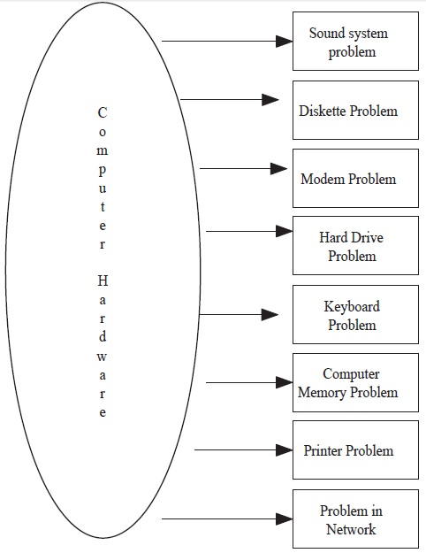

Figure 1.1 Different problem modules of computer hardware faults

**DEBUGGING PROCESS:**

Normally the first step in debugging is to attempt to reproduce the problem. This can be a non-trivial task, for example as with parallel processes or some unusual software bugs. Also, specific user environment and usage history can make it difficult to reproduce the problem. After the bug is reproduced; the input of the program may need to be simplified to make it easier to debug. For example, a bug in a compiler can make it crash when parsing some large source file. However, after simplification of the test case, only few lines from the original source file can be sufficient to reproduce the same crash. Such simplification can be made manually, using a divide-and-conquer approach.

**CHAPTER 2:**

**LITERATURE REVIEW**

One of the most important early steps in a research project is the conducting of the literature review. This is also one of the most humbling experiences you're likely to have. Why? Because you're likely to find out that just about any worthwhile idea you will have has been thought of before, at least to some degree. A literature review is designed to identify related research, to set the current research project within a conceptual and theoretical context. When looked at that way, there is almost no topic that is so new or unique that we can't locate relevant and informative related research.

Some tips about conducting the literature review. First, concentrate your efforts on the scientific literature. Try to determine what the most credible research journals are in your topical area and start with those. Put the greatest emphasis on research journals that use a blind review system. In a blind review, authors submit potential articles to a journal editor who solicits several reviewers who agree to give a critical review of the paper. Second, do the review early in the research process. You are likely to learn a lot in the literature review that will help you in making the tradeoffs you'll need to face. After all, previous researchers also had to face tradeoff decisions.

What should you look for in the literature review? First, you might be able to find a study that is quite similar to the one you are thinking of doing. Since all credible research studies have to review the literature themselves, you can check their literature review to get a quick-start on your own. Second, prior research will help assure that you include all of the major relevant constructs in your study. You may find that other similar studies routinely look at an outcome that you might not have included. If you did your study without that construct, it would not be judged credible if it ignored a major construct. Third, the literature review will help you to find and select appropriate measurement instruments. You will readily see what measurement instruments researchers use themselves in contexts similar to yours. Finally, the literature review will help you to anticipate common problems in your research context. You can use the prior experiences of other to avoid common traps and pitfalls. Try to determine what the most credible research journals are in your topical area and start with those. Put the greatest emphasis on research journals that use a blind review system

* **Research Variables**

*Literature*: - In this part of the study, definition and citations from other authors of the dependent and independent variables in the similar area of research will be presented here.

*Addition*: - We seek all the information throughout the world for new and latest addition all over to provide best things to our customers for their ease. Easy way to find the faults of system and also use as an shopping site to buy the components and even systems.

* **Purchase Intention**

*Literature*: - From the study of Pan (2007, p.5), the author cited from Engel, Blackwell and Miniard (1990), that defines purchasing intention as a psychological process of decision-making. According to Pan (2007), "purchasing decision process" is when the relevant information is searched by the consumers that are motivated by the fulfillment of demands according to personal experience and the external environment; then after accumulating a certain amount of information, they begin to evaluate and consider; and finally after comparison and judgment, they make the decision on certain products.

*Addition*: - We provide best quality and durability. We provide the system which can solve our hardware problems easily. We provide better transaction facilities to costumers and proving free shipping of their product.

* **Time saving**

*Literature*: -Time is also perceived as one of a factor that relates with intention to go to the shop and ask for help to repaired our system and purchase in a shopping context. It is believed that consumers have their own perception of time, whether or not to shop from the internet. According to Hansen and Jensen (2009), accomplishing the shopping trip as soon as possible refers to the time-saving oriented consumers and they prefer store choices favoring quick shopping; people who dislike shopping and approaching for time saving retail stores refers to the economic shoppers or known as "problem-solvers".

*Addition*: - SYSTEM DEBUGGER is a time saving site because its troubleshooting and shopping site and we provide them a short period shipping of their products and customer can give valuable feedback for better next time.

* **High Interactivity**

*Literature*: -Interactivity is defined as the degree to which two or more communication parties can act on each other, on the communication medium, and on the messages and the degree to which such influences are synchronized (Liu and Shrum, 2002, p.54). According to McMillan and Hwang (2002), interactivity is defined as direction of communications, user control and time. Interactivity can be applied in online and offline shopping. The terms of interactivity in an online context is based on the detailed information given, easy-to-read or descriptive information is available (Park and Stoel, 2005) and also the degree of communication between the buyer and the seller.

*Addition*: - Easy steps to review, providing cell numbers, e-mail and feedback form for customers .It is highly eye catching. It is perfect debugger.

**CHAPTER3:**

**PROBLEM FORMULATION AND METHEDOLOGY**

**PROBLEM FORMULATION**

So how do researchers come up with the idea for a research project? Probably one of the most common sources of research ideas is the experience of **practical problems in the field.** Many researchers are directly engaged in social, health or human service program implementation and come up with their ideas based on what they see happening around them. Others aren't directly involved in service contexts, but work with (or survey) people who are in order to learn what needs to be better understood. Many of the ideas would strike the outsider as silly or worse. For instance, in health services areas, there is great interest in the problem of back injuries among nursing staff. It's not necessarily the thing that comes first to mind when we think about the health care field. But if you reflect on it for a minute longer, it should be obvious that nurses and nursing staff do an awful lot of lifting in performing their jobs. They lift and push heavy equipment, and they lift and push oftentimes heavy patients! If 5 or 10 out of every hundred nursing staff were to strain their backs on average over the period of one year, the costs would be enormous -- and that's pretty much what's happening. Even minor injuries can result in increased absenteeism. Major ones can result in lost jobs and expensive medical bills. The nursing industry figures that this is a problem that costs tens of millions of dollars annually in increased health care.

**SYSTEM ANALYSIS:**

System analysis by definition is a process of systematic investigation for the purpose of gathering data, interpreting the facts, diagnosing the problem, and using this information to either build completely new software or to recommend the improvements to the existing software. The analysis model must achieve three primary objectives: The Analysis model:

* To describe what the customer requires.
* To establish the basis for the enhancement of a software design.
* To define a set of requirements that can be validated once the software is completely enhanced. The main elements of the analysis model are briefly described below.
* At the core of the model lies the data dictionary, which is a repository that contains descriptions of all the data objects consumed or produced by the software .Three different diagrams surround the core.
* The entity relation diagram depicts relationships between data objects.
* The data flow diagram provides an indication of how the data is transformed as they move through the system.
* The state transition diagram indicates how the system behaves as a consequence of external events.

**SYSTEM SPECIFICATIONS:**

* **HARDWARE REQUIREMENTS:**
* Pentium-IV (Processor).
* 256 MB Ram
* 512 KB Cache Memory
* Hard disk 10 GB
* Microsoft Compatible 101 or more Key Board
* **SOFTWARE REQUIREMENTS:**
* **Operating System :** Windows
* **Programming language:** PHP
* **Front-End:** HTML, PHP, J-query, Java script, CSS
* **Back-End:** MYSQL
* **Web Server:** WAMP Server

**WORK DONE**

In the initial phase our project in-charge teaches us the aim, objective and the purpose of the project we are suppose to make. After that the database layer structuring of the project is done step by step by making tables and then inserting the entries in their fields according to our need.

Then the designing part of our website is done, i.e. how the website appears to the user is completed accordingly. Then the development phase of our project is done in which the CSS file is made which is the most critical part of the project, along with content pages is done. Database for the new registration and the user is finalized and presentation layer for the login and logout section are completed.

After that the database for problem solution and causes are made so that one should overcome with their problems by simply login into the website and user can find his/her solution according to the problem the user is facing in its computer system.

In this debugger user can also buy the components for its system. We also added the shopping part in our website. Dual work is done in single website. User can also buy laptops of different companies according to wish. User has to simply login and then he/she can view the products and system and the review its specifications and can buy by simply clicking on buy now button. Bill for the user will be generated according to all the requirements.

System debugger is introduced to develop hardware fault detection for any computer system. Different hardware system or electronics devices usually face application fault as well as hardware fault. This application oriented formal reasoning applies to determine the problem in computer system. This project emphasizes an automated system that accepts the defects of any system and then after consulting with an intelligent database, diagnoses and advises for probable rectification. This project extends that concept exploring the boundary of Expert System targeting the implementation using Object Oriented web based programming approach. It proposes lot of new technological changes and inclusion to make the system more perfective and efficient data handler.

**PROPOSED WORK**

1. **Login Module:**

Customer can enter into the website by logging into the website. It contains two modules for login. For login, registration is done by the customer and login id and password are provided to the user.

1. **Add details :**

User can add details by filling into registration form. User can upload the image.

1. **Choose problem:**

User can choose problem according to their system and can find solution.

1. **Buy products:**

Users can buy products and can review all the details of the product by read more reference.

1. **Update account information:**

User can update or change the user account details like as change the user name, change the password, change the email address.

1. **Delete User:**

We can delete the user detail or delete the user by going in to the registration tab

**OVERVIEW OF METHODOLOGY**

**INTRODUCTION TO PHP :**

PHP is a technology that lets you mix regular, static HTML with dynamically-generated HTML. Many Web pages that are built by CGI programs are mostly static, with the dynamic part limited to a few small locations. But most CGI variations, including servlets, make you generate the entire page via your program, even though most of it is always the same.

PHP is a widely used, general-purpose [scripting language](http://en.wikipedia.org/wiki/Scripting_language) that was originally designed for [web development](http://en.wikipedia.org/wiki/Web_development), to produce [dynamic web pages](http://en.wikipedia.org/wiki/Dynamic_web_page). It can be embedded into [HTML](http://en.wikipedia.org/wiki/HTML) and generally runs on a [web server](http://en.wikipedia.org/wiki/Web_server), which needs to be configured to process PHP code and create [web page](http://en.wikipedia.org/wiki/Web_page) content from it. It can be deployed on most web servers and on almost every [operating system](http://en.wikipedia.org/wiki/Operating_system) and [platform](http://en.wikipedia.org/wiki/Platform_%28computing%29) free of charge. PHP is installed on over 20 million websites and 1 million [web servers](http://en.wikipedia.org/wiki/Web_server).

For example, if you are creating an online catalog, you will most likely have a design template for all related catalog pages. Traditionally, this design is generated by hand in HTML and different data is presented within the template design. With PHP, one application can be used to generate all the pages required to display items from a database in the proper pages, in the right locations, and with the appropriate related content. This eliminates redundant page generation, simplifying maintenance. PHP also reduces the site down to a handful of template pages, with scripts that generate the rest of the site

PHP was originally created by [RasmusLerdorf](http://en.wikipedia.org/wiki/Rasmus_Lerdorf) in [1994](http://en.wikipedia.org/wiki/1995) and has been in continuous development ever since. The main implementation of PHP is now produced by The PHP Group and serves as the [de facto standard](http://en.wikipedia.org/wiki/De_facto_standard) for PHP as there is no [formal specification](http://en.wikipedia.org/wiki/Formal_specification). PHP is [free software](http://en.wikipedia.org/wiki/Free_software) released under the [PHP License](http://en.wikipedia.org/wiki/PHP_License), which is incompatible with the [GNU General Public License](http://en.wikipedia.org/wiki/GNU_General_Public_License) (GPL) because of restrictions on the use of the term PHP .

**INTRODUCTION TO MYSQL :**

**MySQL** is a [relational database management system](http://en.wikipedia.org/wiki/Relational_database_management_system) (RDBMS) which has more than 6 million installations. MySQL stands for "My Structured Query Language". The program runs as a server providing multi-user access to a number of databases.

The project's [source code](http://en.wikipedia.org/wiki/Source_code) is available under terms of the [GNU General Public License](http://en.wikipedia.org/wiki/GNU_General_Public_License), as well as under a variety of [proprietary](http://en.wikipedia.org/wiki/Proprietary_software) agreements. MySQL is owned and sponsored by a single [for-profit](http://en.wikipedia.org/wiki/Business) firm, the [Swedish](http://en.wikipedia.org/wiki/Sweden) company [MySQL AB](http://en.wikipedia.org/wiki/MySQL_AB), now a [subsidiary](http://en.wikipedia.org/wiki/Subsidiary) of [Sun Microsystems](http://en.wikipedia.org/wiki/Sun_Microsystems), which holds the copyright to most of the codebase.

MySQL is commonly used by [free software](http://en.wikipedia.org/wiki/Free_software) projects which require a full-featured database management system, such as [WordPress](http://en.wikipedia.org/wiki/WordPress), [phpBB](http://en.wikipedia.org/wiki/PhpBB) and other software built on the [LAMP](http://en.wikipedia.org/wiki/LAMP_%28software_bundle%29) software stack. It is also used in very high-scale [World Wide Web](http://en.wikipedia.org/wiki/World_Wide_Web) products including [Google](http://en.wikipedia.org/wiki/Google) and [Facebook](http://en.wikipedia.org/wiki/Facebook).

**Features of SQL Server**

* Information representation
* Unique definition of rows
* Systematic treatment of Null values
* Guaranteed access
* High level Update, Insert, and Delete
* Retrieving information from the database.
* Accepting query language statements.
* Enforcing security specifications.
* Enforcing data integrity specification
* Enforcing transaction consistency
* Managing data sharing
* Optimizing queries

**CHAPTER 4:**

**IMPLEMENTATION**

Implementation includes all those activities that take place to convert from old system to the new one. Implementation uses the design document to produce code. Demonstration that the program satisfies its specification validates the code. Small programs are written using the model. It may take several iteration of the model to produce a working program. We have to write programs in a manner that will help insure that errors are caught or avoided. There are some rules for coding that we have to follow writing the code using the rules when make sure that the code is simple readable and understandable.

* **Name:**  Variable name should be proper because they reflect some process and entity in the domain. Name should be as real world. So I tried to be proper naming.
* **Control constructs:** As much as possible, it is desirable to use single entity, single exit constructs.
* **Nesting:** Tries to avoid deep nesting because it very difficult to understand. So I tried to avoid it.

**Incremental program development:**

As programs become more complex, changes have a tendency to introduce unexpected effects. Incremental programming tries to isolate the effects of changes. We have added new features in preference to adding new functions, and add new function rather than writing new programs. The program incremental model becomes:

1. Define types/compile/fix;
2. Add load and dump functions/compile test;
3. Add first processing function/compile test/fix;
4. Add features/compile test/fix;
5. Add second processing function/compile test/fix;

**DFD(DATA FLOW DIAGRAM):**

Data flow diagrams (DFD) was first developed by LARRY CONSTANTINE as way representing system requirements in a graphical form; this lead to modular design. A DFD describes what data flow (logical) rather than how they are processed, so it does not depend on hardware, software, data structure or file organization. It is also known as ‘bubble chart’.

A Data Flow Diagrams is a structured analysis and design tool that can be used for flowcharting in place of, or in association with, information-oriented and process-oriented systems flowcharts. A DFD is a network that describes the flow of data and the processes that change, or transform, data throughout a system. This network is constructed by using a set of symbols that do not imply a physical implementation.

The symbols used to prepare DFD do not imply a physical implementation, a DFD can be considered to an abstract of the logic of an information-oriented or a process-oriented system flow-chart. For these reasons DFDs are often referred to as logical data flow diagrams.

|  |  |
| --- | --- |
| Symbols | Description |
|  | A RECTANGLE defines a source or Destination of system data. |
|  | A CIRCLE or a BUBBLE represents a process that transforms the incoming  data flows into outgoing data flows |
|  | An open RECTANGLE is a data store: Data at rest, or a temporary repository  Of data. |
|  | ARROW identify the data flow – data In motion. It is a pipeline through which the  information flows |

**RULES FOR DFD:**

* Fix the scope of the system by means of context diagrams.
* Organize the DFD so that the main sequence of the actions.
* Reads left to right and top to bottom.
* Identify all inputs and outputs.
* Identify and label each process internal to the system with Rounded circles.
* A process is required for all the data transformation and Transfers. Therefore, never connect a data store to a data Source or the destinations or another data store with just a Data flow arrow.
* Do not indicate hardware and ignore control information.
* Make sure the names of the processes accurately convey everything the process is done.
* There must not be unnamed process.
* Number each occurrence of repeated external entities.
* Label data flow on each arrow.
* Use details flow on each arrow.
* Use the details flow arrow to indicate data movements.

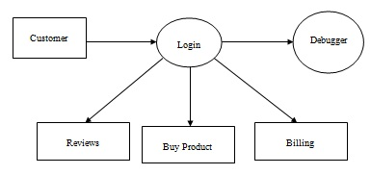

Figure 4.1 Level 0 DFD

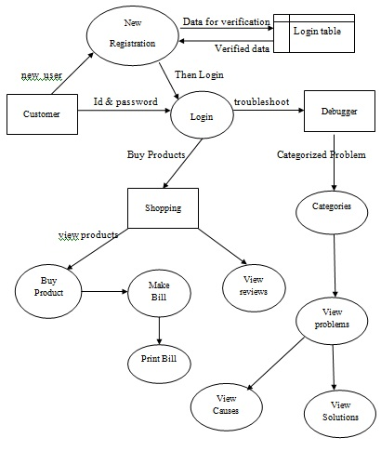

Figure 4.2 Level 1 DFD

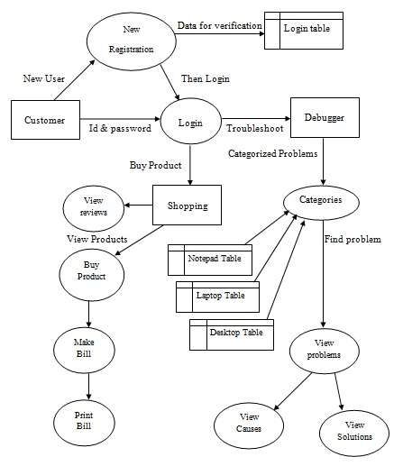

Figure 4.3 Level 2 DFD

**ER DIAGRAM:**

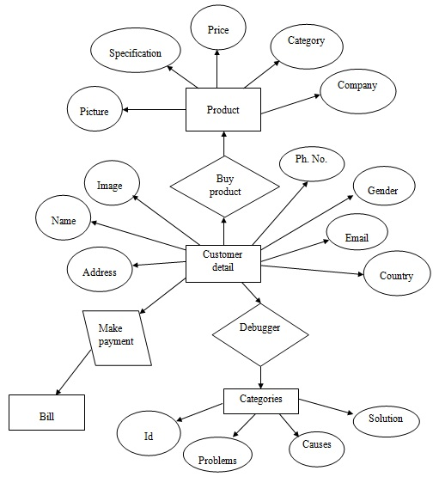

Figure 4.4 Entity Relationship Diagram

**UML DIAGRAM:**

UML stands for Unified Modeling Language. UML is a language for specifying, visualizing and documenting the system. This is the step while developing any product after analysis. The goal from this is to produce a model of the entities involved in the project which later need to be built. The representations of the entities that are to be used in the product being developed are needed to be designed.

**Actor:** A coherent set of roles that users of use cases play when interacting with the use `cases.

**Use case:**

A description of sequence of actions, including variants, that a system performs that yields an observable result of value of an actor.

There are various kinds of diagrams in UML diagram:

They are as follows:

* Use case Diagram
* Sequence Diagram
* Collaboration Diagram
* Activity Diagram
* State chat Diagram

**USECASE DIAGRAMS:**

Use case diagrams model behavior within a system and helps the developers understand of what the user require. The stick man represents what’s called anactor. Use case diagram can be useful for getting an overall view of the system and clarifying that can do and more importantly what they can’t do. Use case diagram consists of use cases and actors and shows the interaction between the use case and actors.

* The purpose is to show the interactions between the use case and actor.
* To represent the system requirements from user’s perspective.
* An actor could be the end-user of the system or an external system.

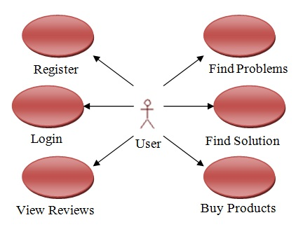

Figure 4.5 Use Case Diagrams

**SEQUENCE DIAGRAM:**

Sequence diagram and collaboration diagram are called INTERACTION DIAGRAMS. An interaction diagram shows an interaction, consisting of set of objects and their relationship including the messages that may be dispatched among them.

A sequence diagram is an introduction that empathizes the time ordering of messages. Graphically a sequence diagram is a table that shows objects arranged along the X-axis and messages ordered in increasing time along the Y-axis

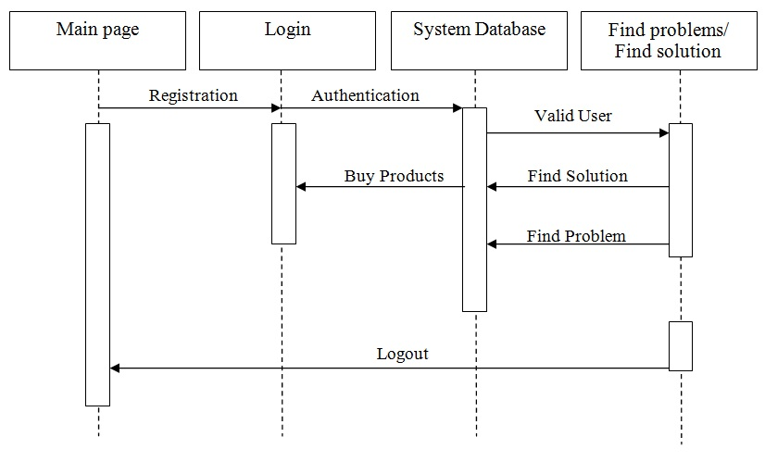

Figure 4.6 Sequence Diagram

**COLLABORATION DIAGRAM:**

A collaboration diagram is an introduction diagram that emphasizes the structural organization of the objects that send and receive messages. Graphically a collaboration diagram is a collection of vertices and arcs.

A collaboration diagram describes interactions among objects in terms of sequenced messages. Collaboration diagrams represent a combination of information taken from class, sequence, and use case diagrams describing both the static structure and dynamic behavior of a system

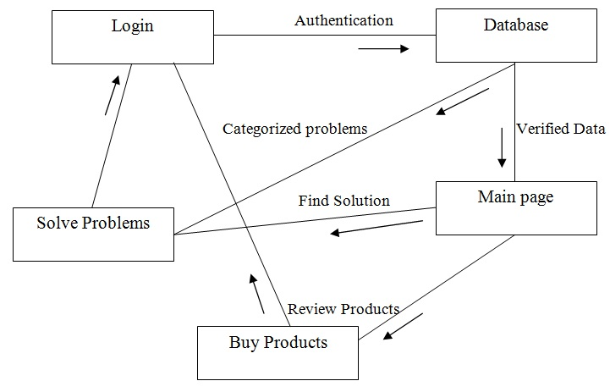

Figure 4.7 Collaboration Diagram

**STATE CHART DIAGRAM:**

State chart diagram is used to describe the states of different objects in its life cycle. So the emphasis is given on the state changes upon some internal or external events. These states of objects are important to analyze and implement them accurately.State chart diagrams are very important for describing the states. States can be identified as the condition of objects when a particular event occurs.

Before drawing a State chart diagram we must have clarified the following points:

* Identify important objects to be analyzed.
* Identify the states.
* Identify the events.

The following is an example of a State chart diagram where the state of *Order* object is analyzed.

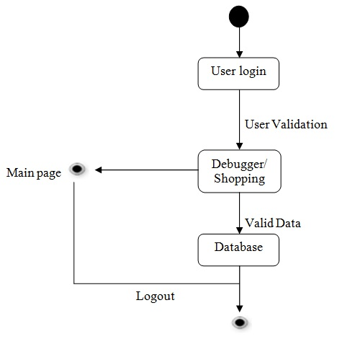

Figure 4.8 State Chart Diagram

**CLASS DIAGRAM:**

Class is nothing but a structure that contains both variables and methods. The Class Diagram shows a set of classes, interfaces, and collaborations and their relating ships. There is most common diagram in modeling the object oriented systems and are used to give the static view of a system. It shows the dependency between the classes that can be used in our system.

The interactions between the modules or classes of our projects are shown below. Each block contains Class Name, Variables and Methods.

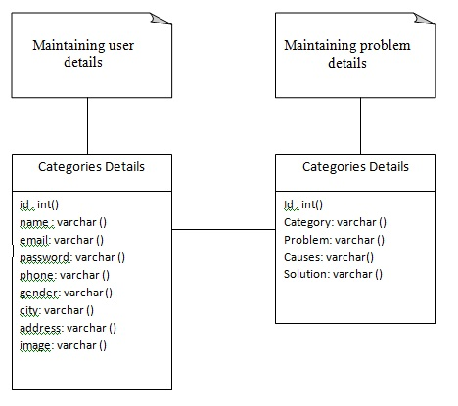

Figure 4.9 Class Diagram

**CHAPTER 5:**

**RESULTS AND DISSCUSSION**

**DATABASE TABLES:**

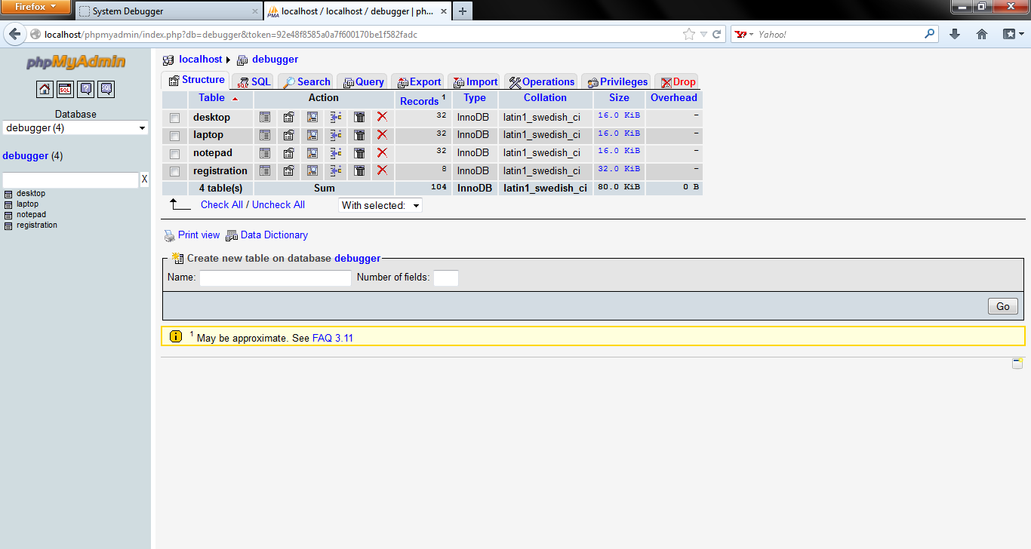

Figure 5.1 Database Tables

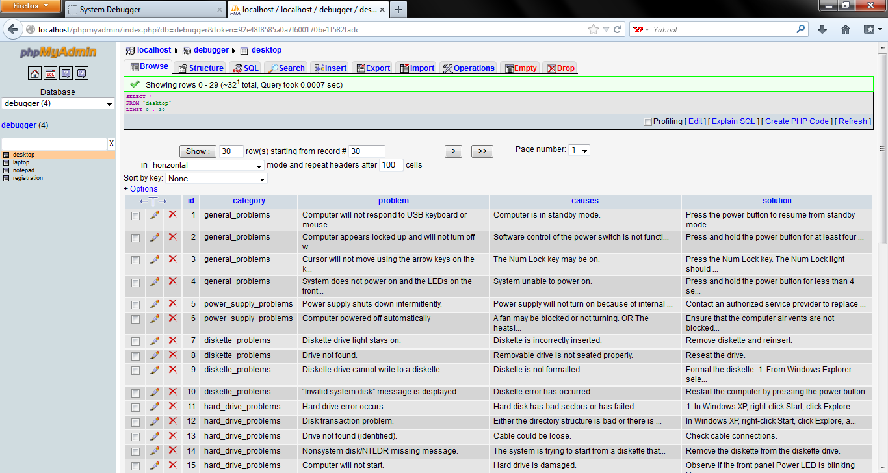

Figure 5.2 Desktop Table Entries

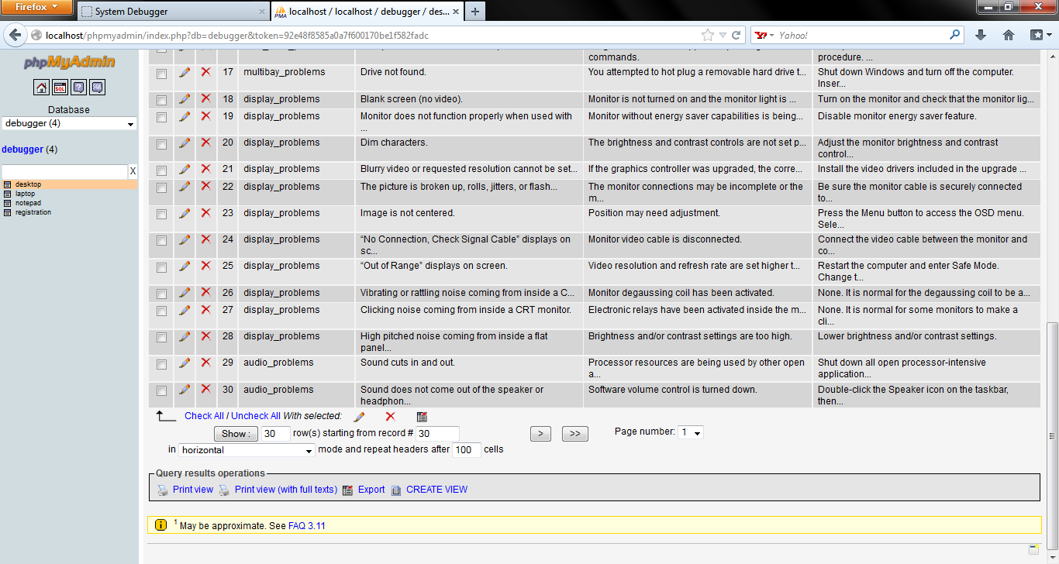

Figure 5.3 Desktop Table Entries_cont.



Figure 5.4 Laptop Table Entries



Figure 5.5 Laptop Table Entries_cont.



Figure 5.6 Notepad Table Entries



Figure 5.7 Notepad Table Entries_cont.

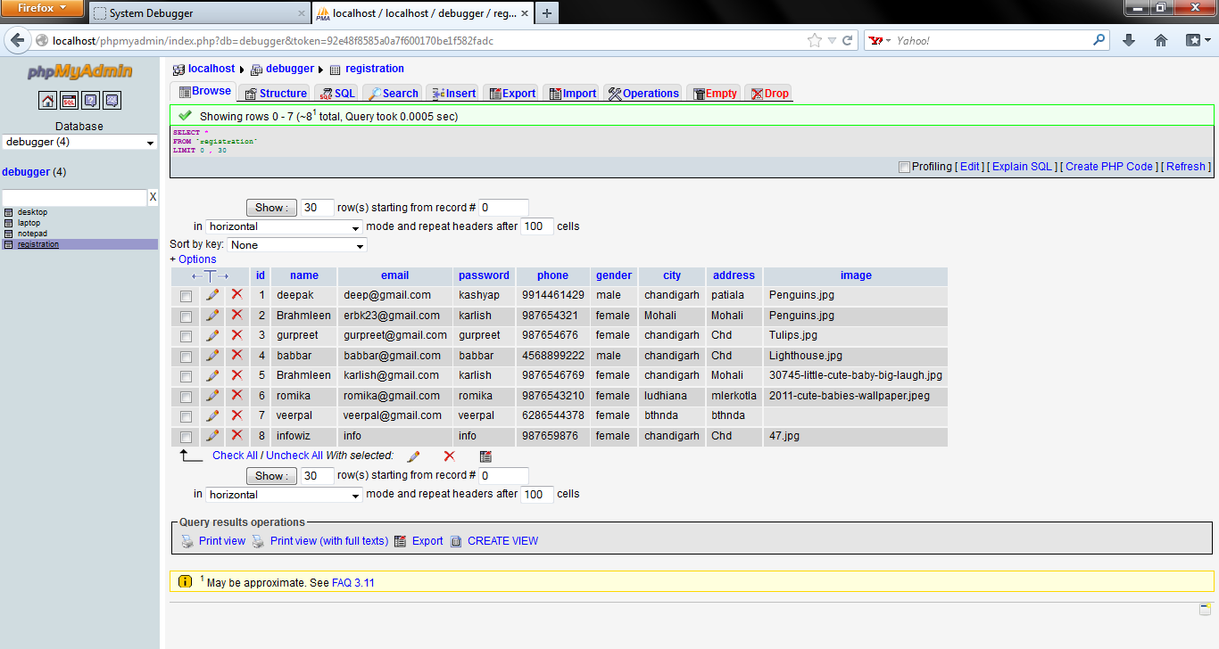

Figure 5.8 Registration Table Entries

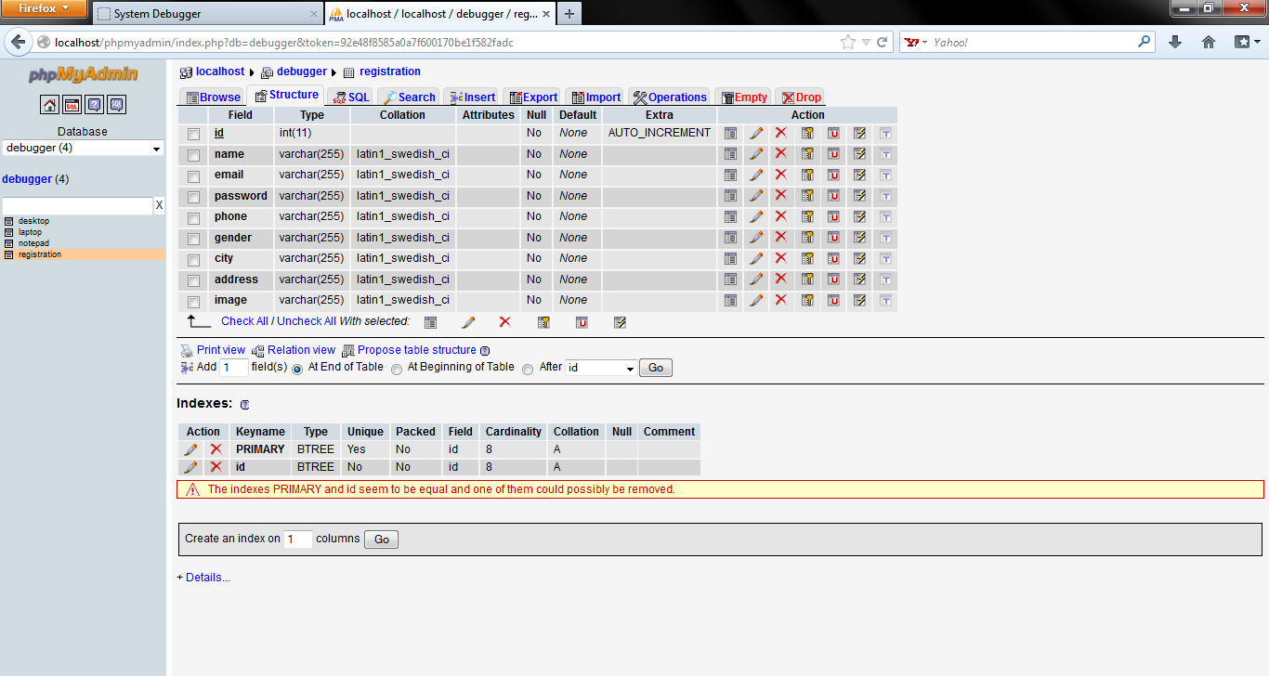

Figure 5.9 Structure of tables

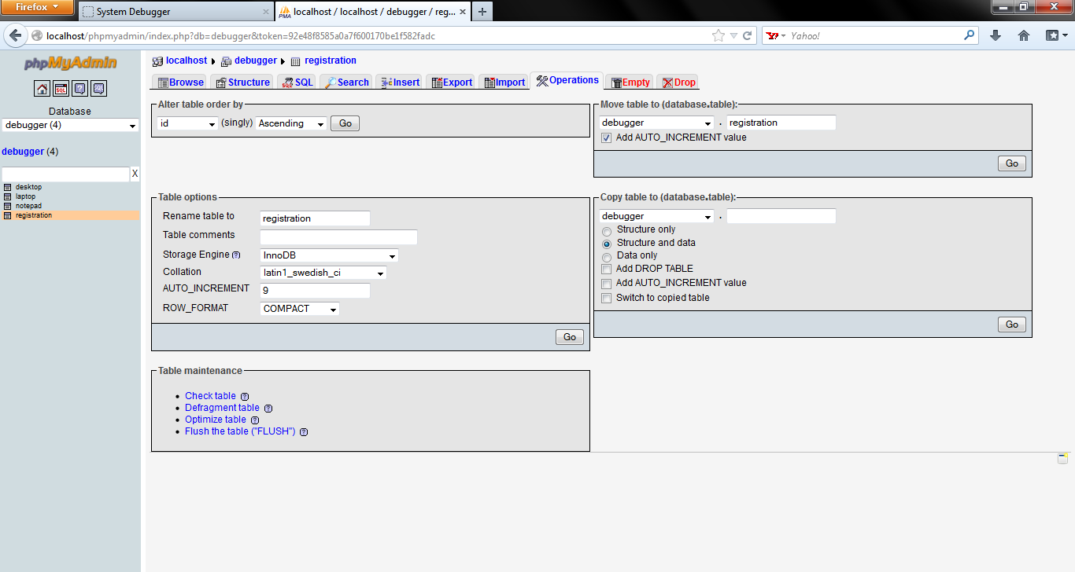

Figure 5.10 Operations Performed on Tables

**SNAPSHOTS:**

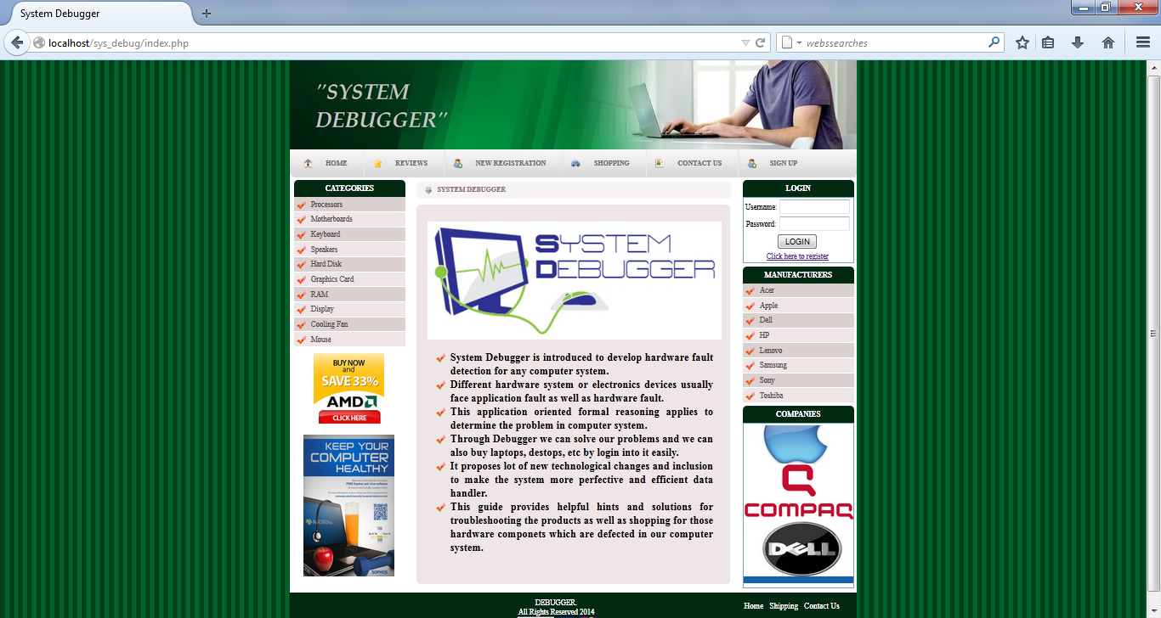

Figure 5.11 Home Page

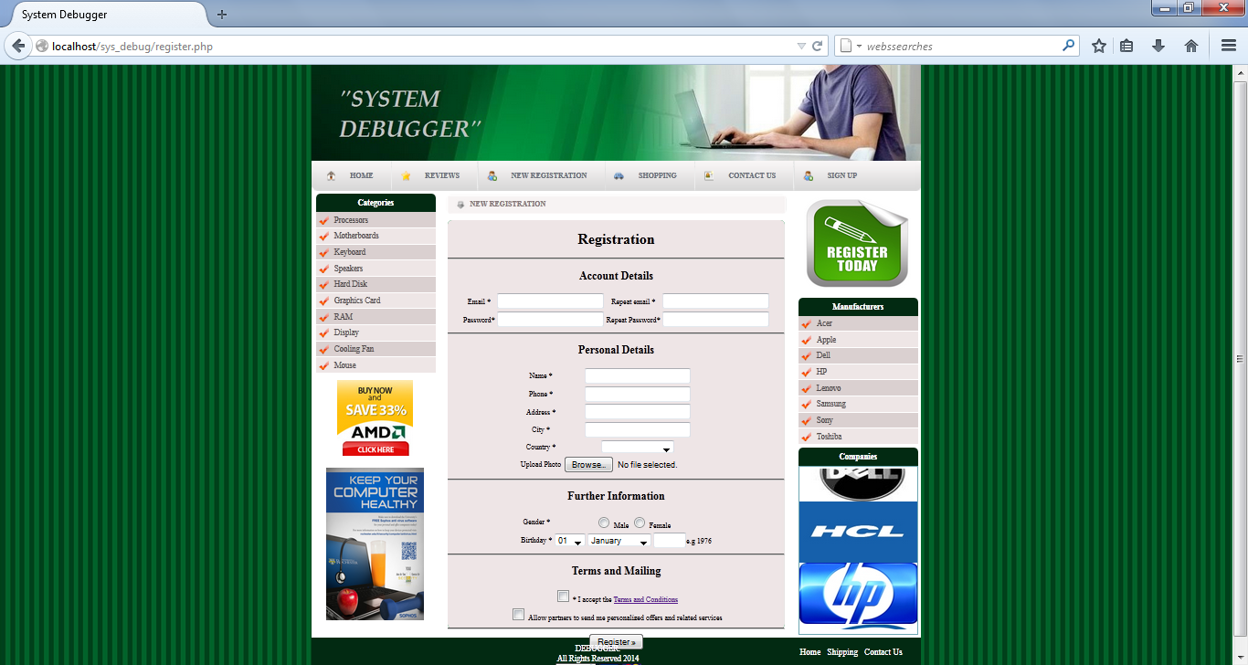

Figure 5.12 Registration Page

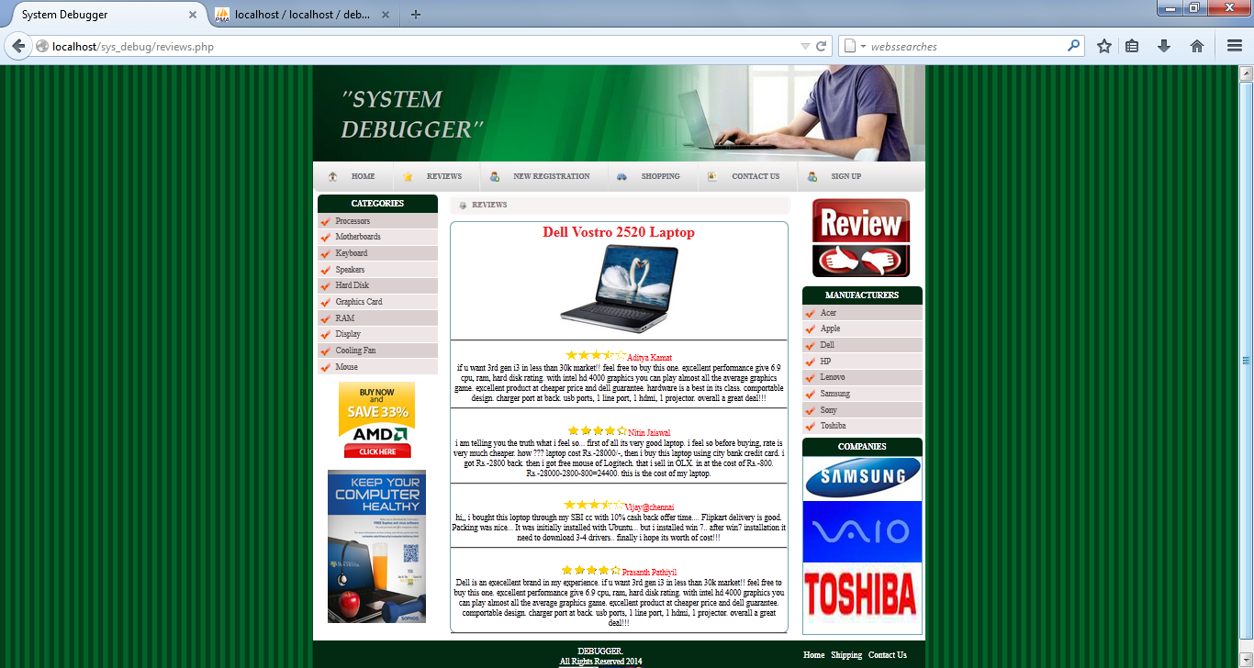

Figure 5.13 Reviews Page

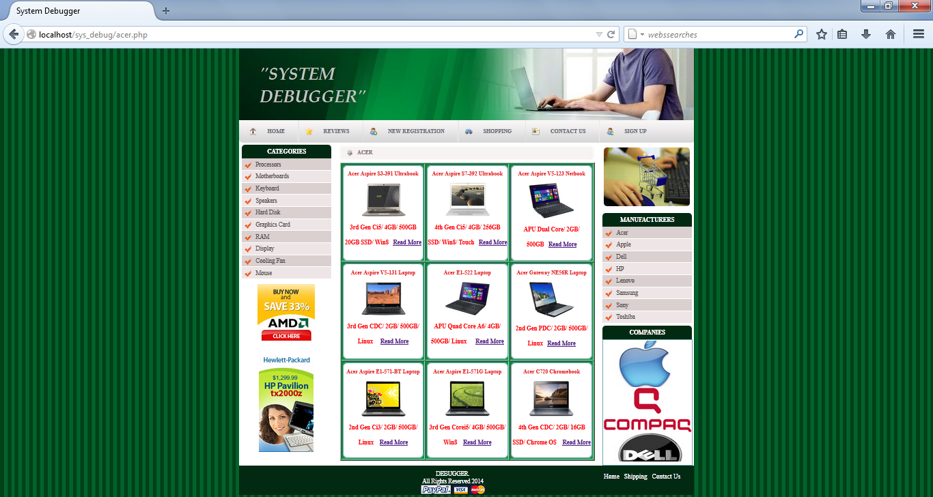

Figure 5.14 Shopping Page

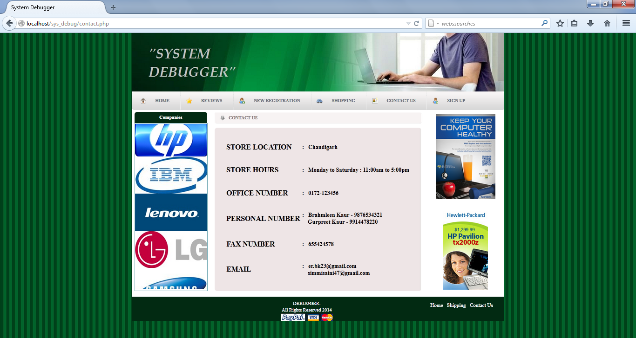

Figure 5.15 Contact Us Page

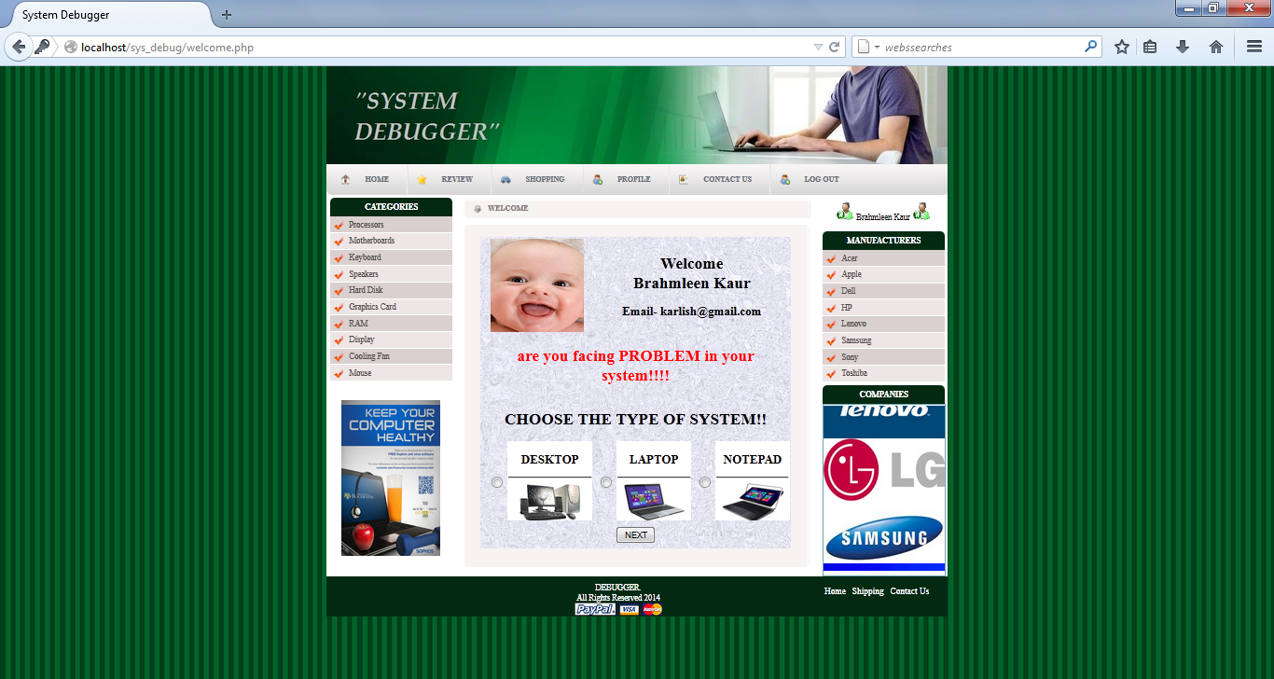

Figure 5.16 Welcome Page

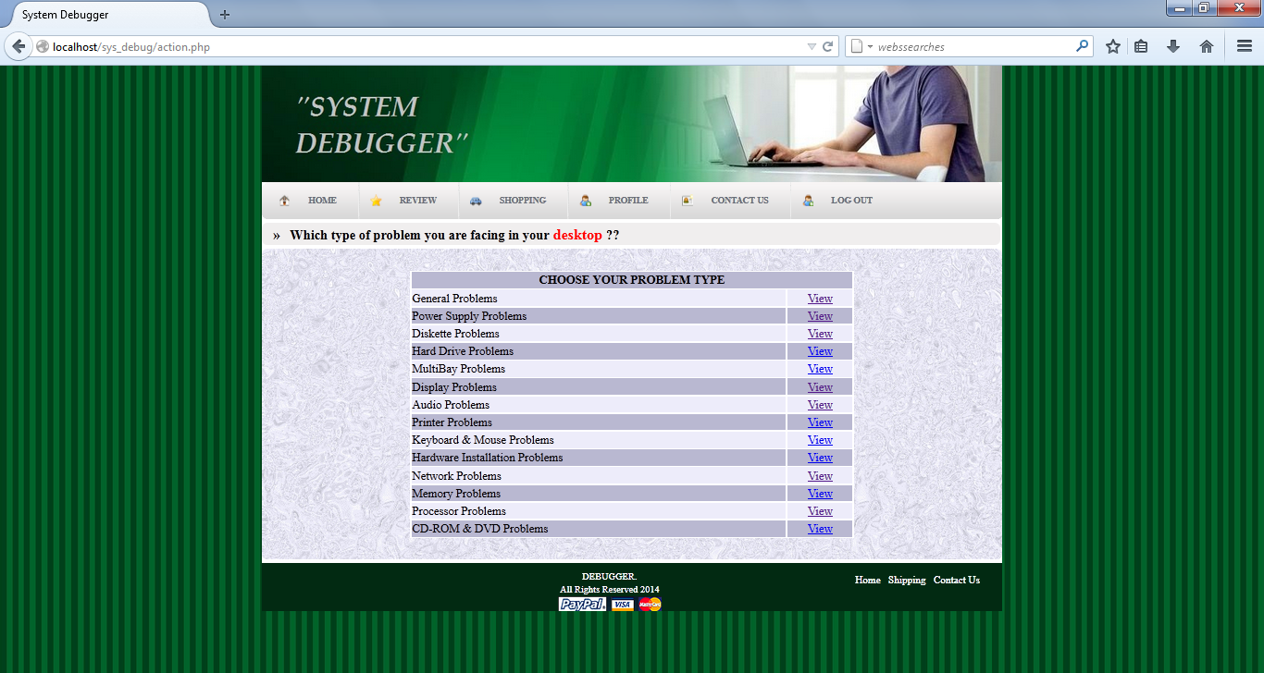

Figure 5.17 Categories Page

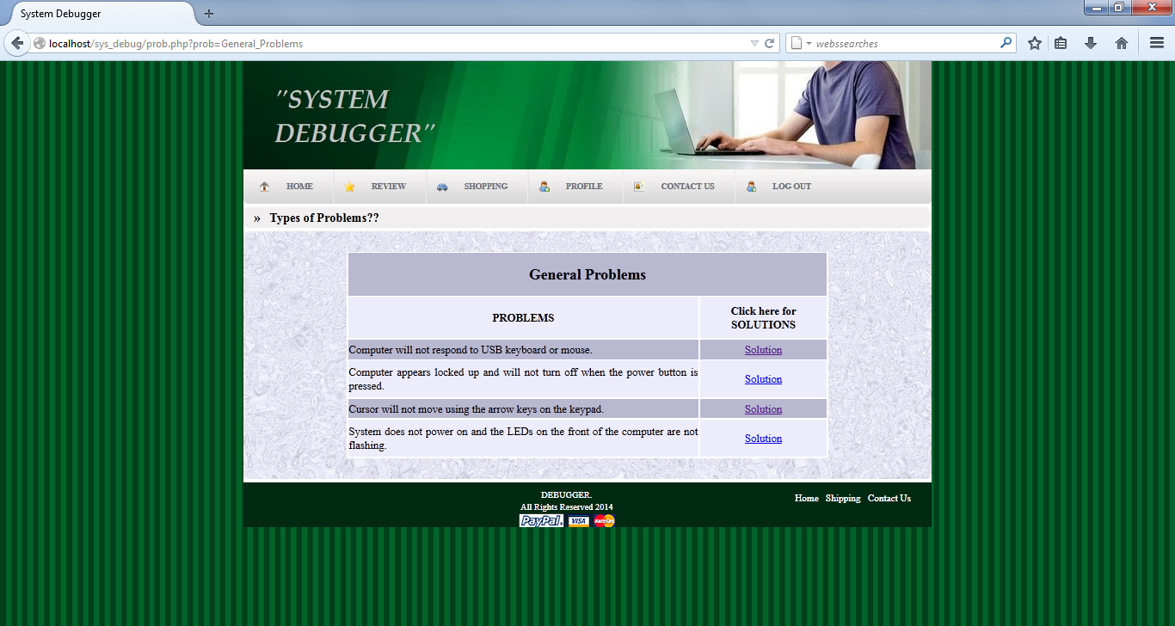

Figure 5.18 Problem Page

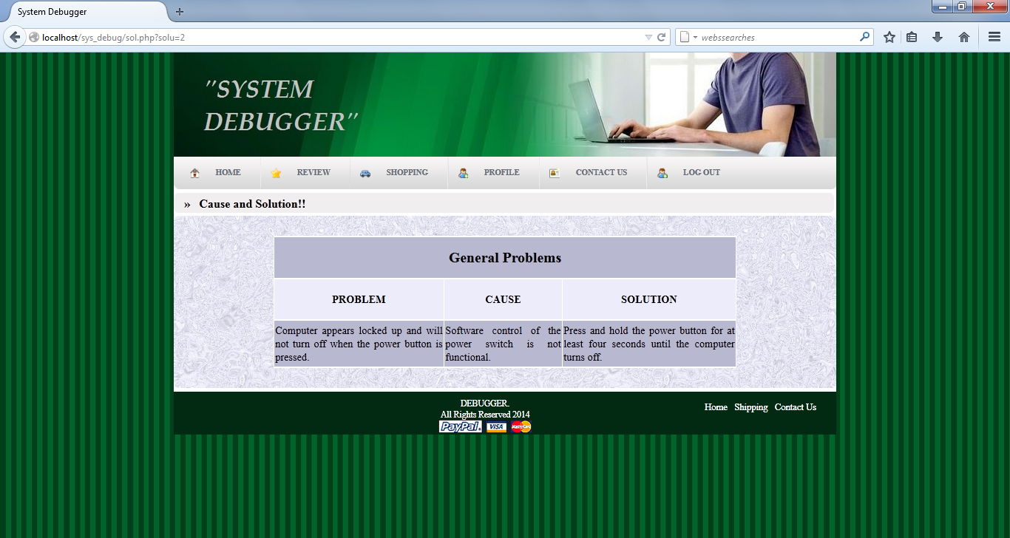

Figure 5.19 Cause/Solution Page

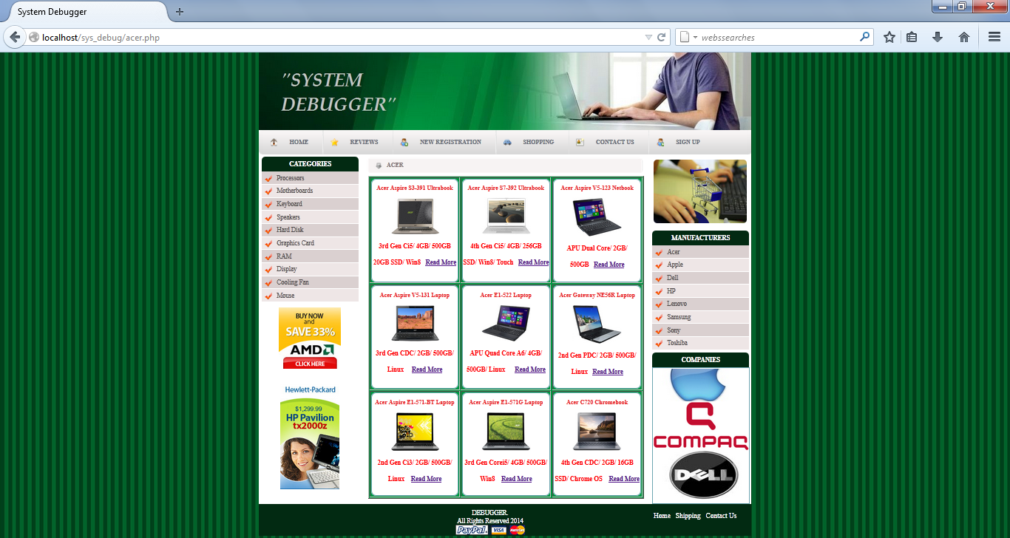

Figure 5.20 Acer Page

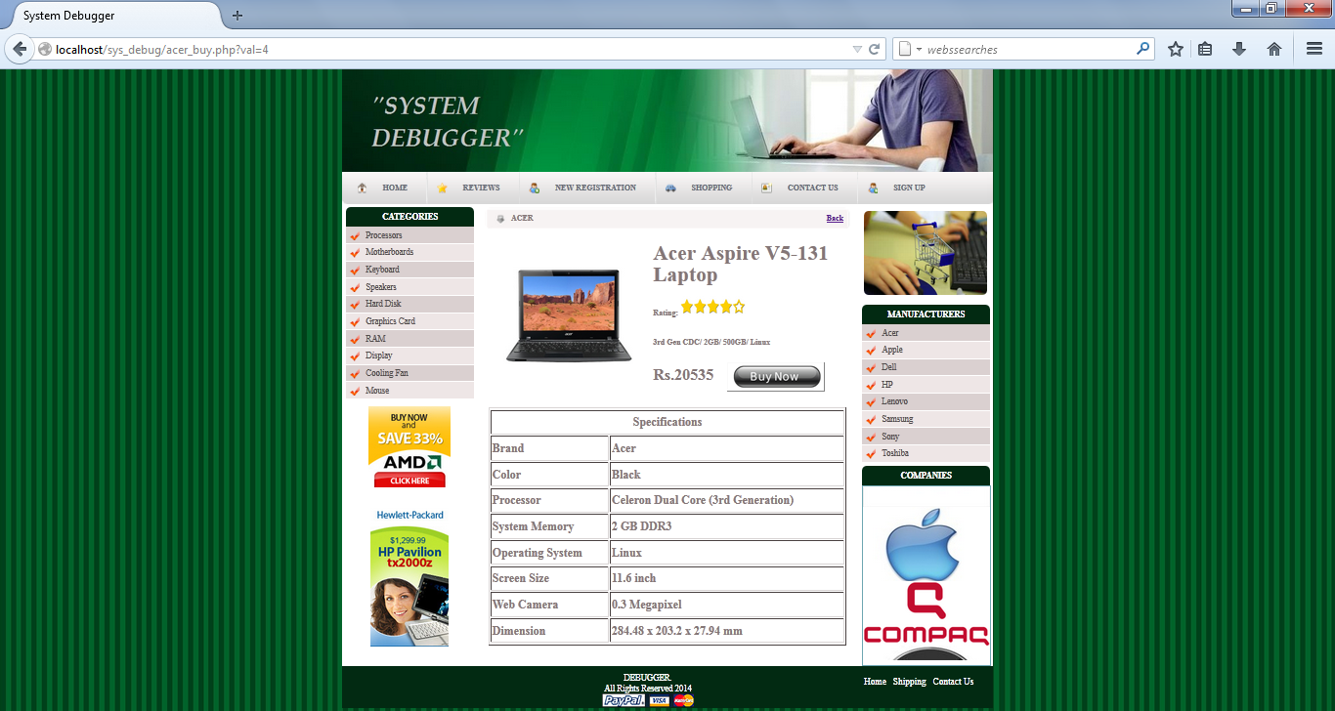

Figure 5.21 Acer Details Page

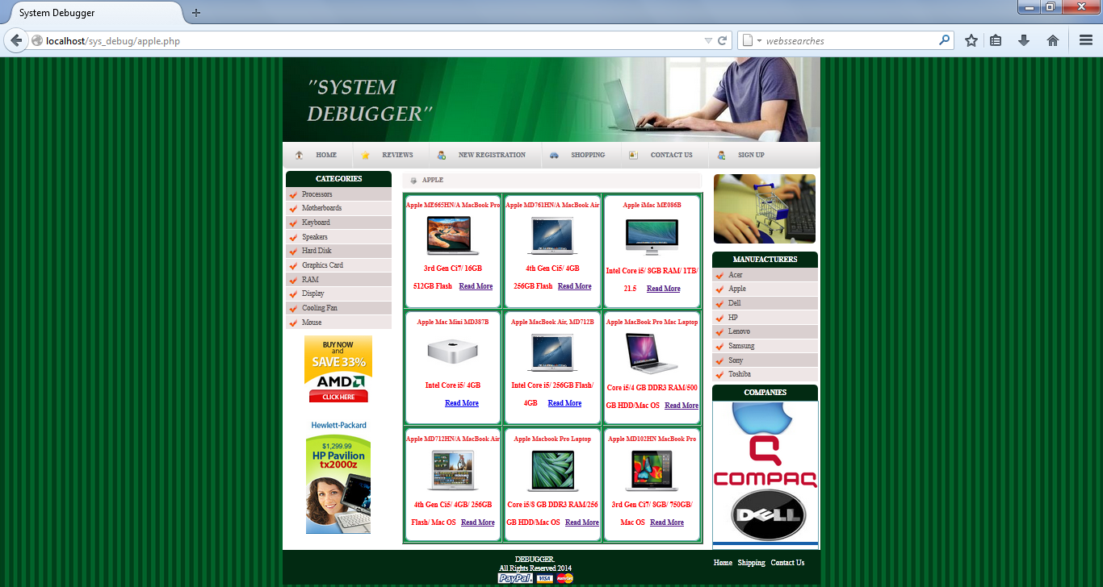

Figure 5.22 Apple Page

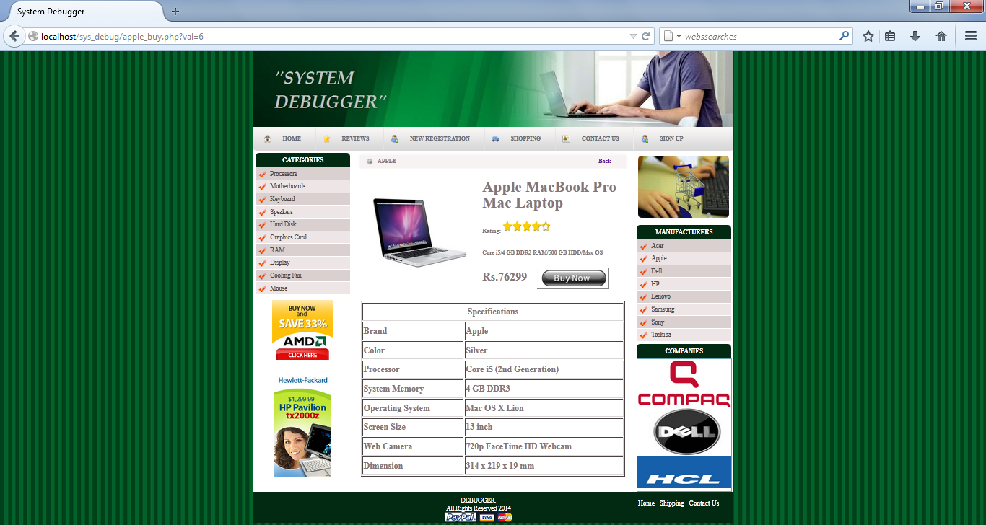

Figure 5.23 Apple Details Page

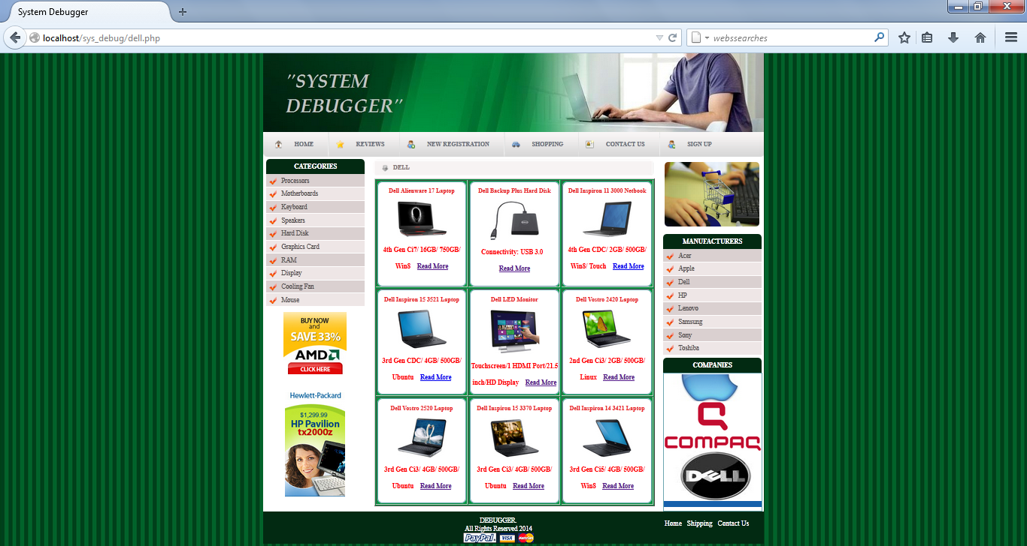

Figure 5.24 Dell Page

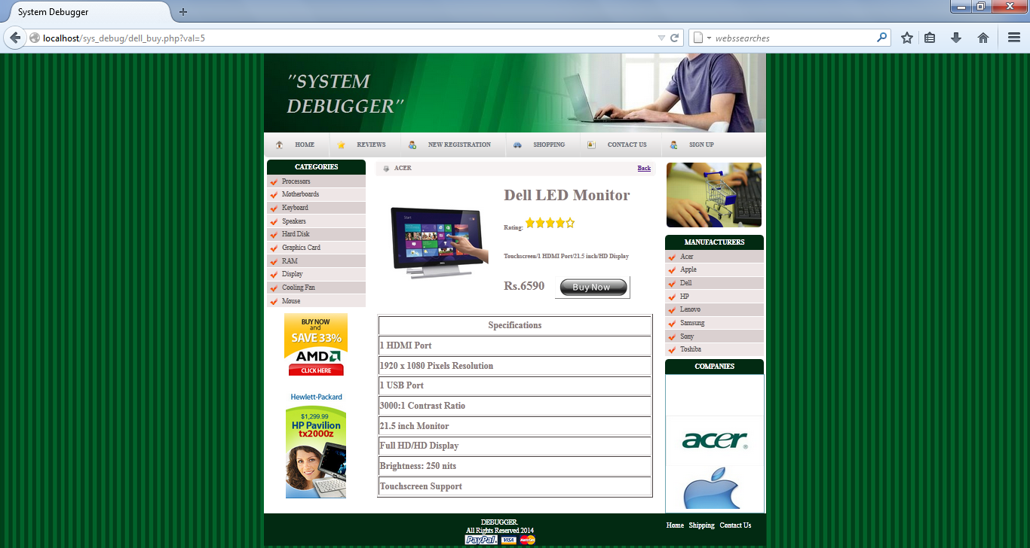

Figure 5.25 Dell Details Page

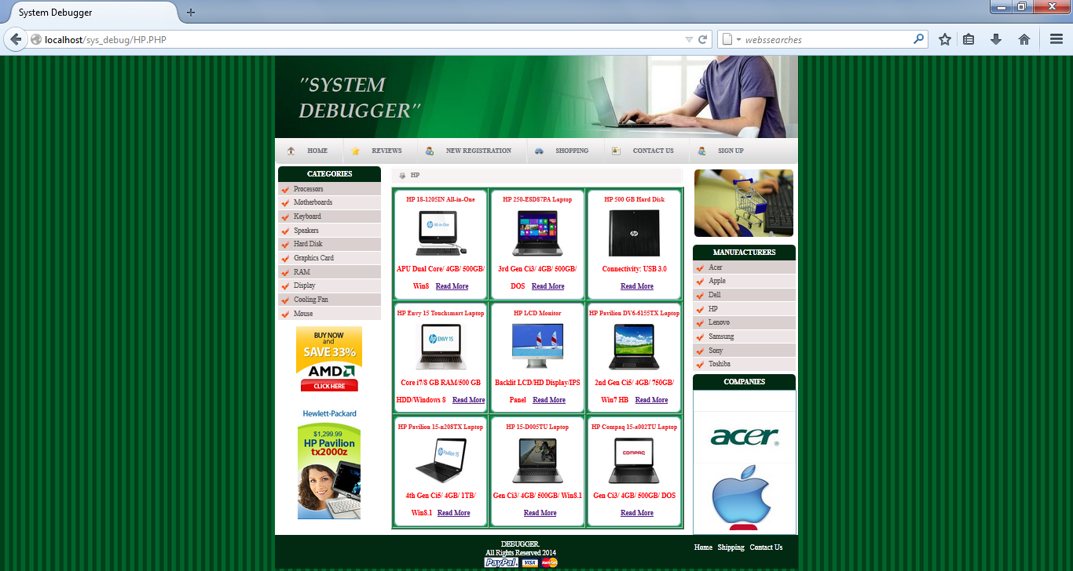

Figure 5.26 HP Page

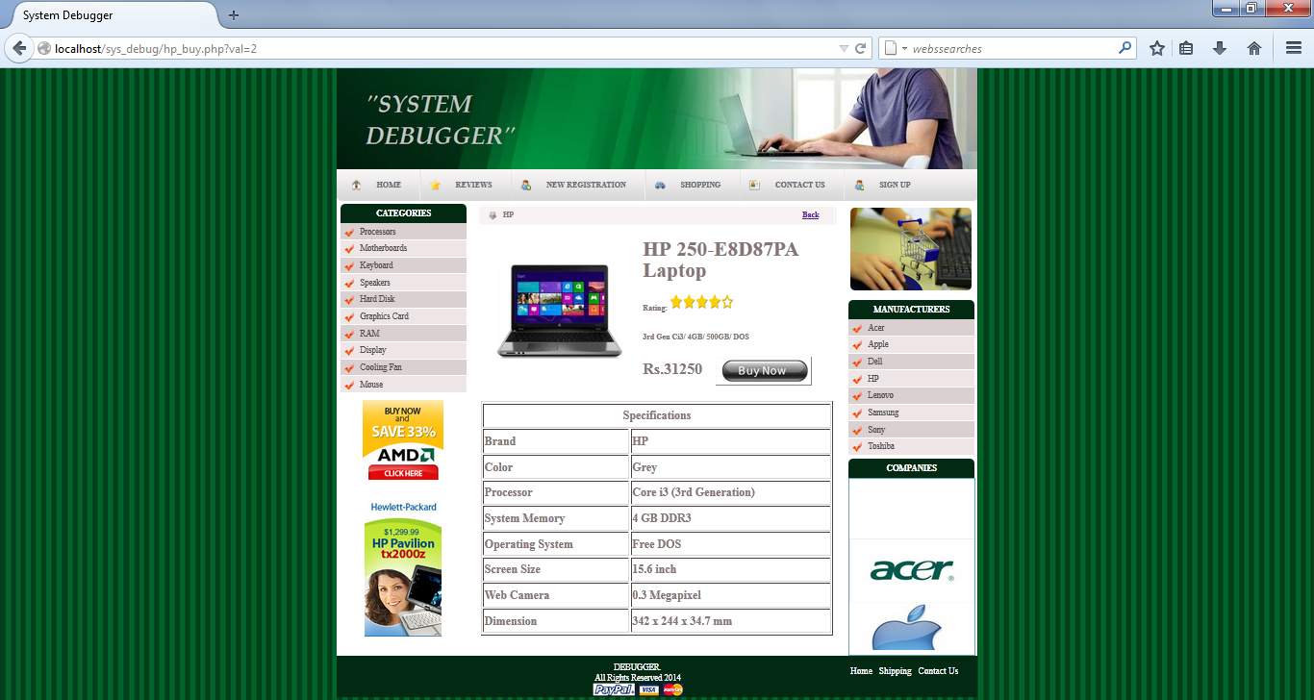

Figure 5.27 HP Details Page

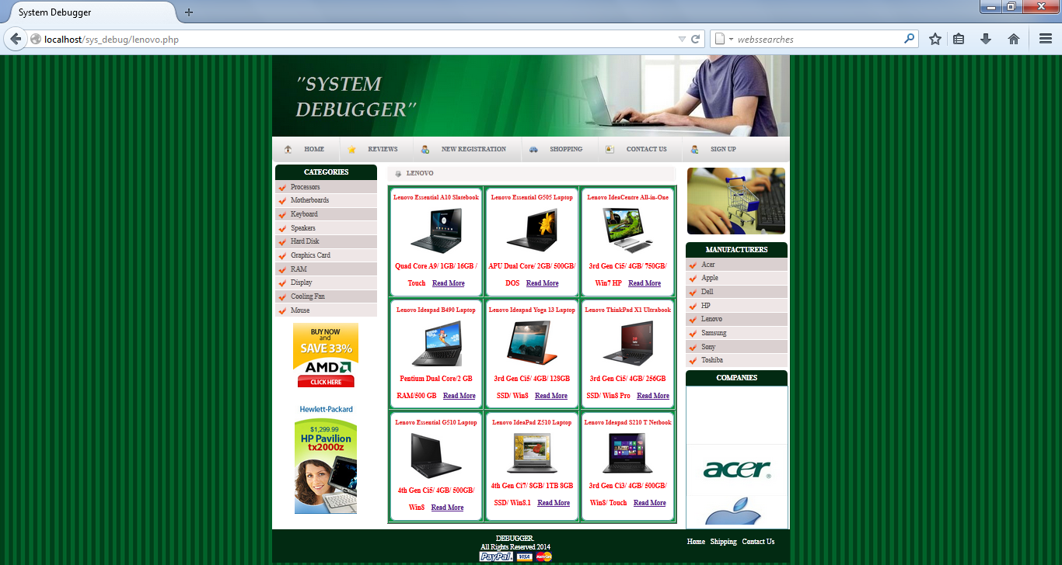

Figure 5.28 Lenovo Page

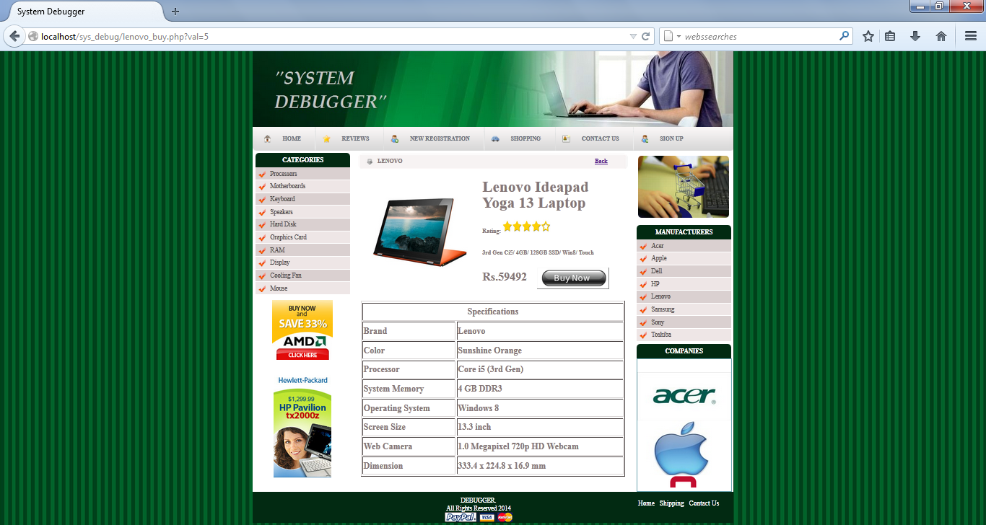

Figure 5.29 Lenovo Details Page

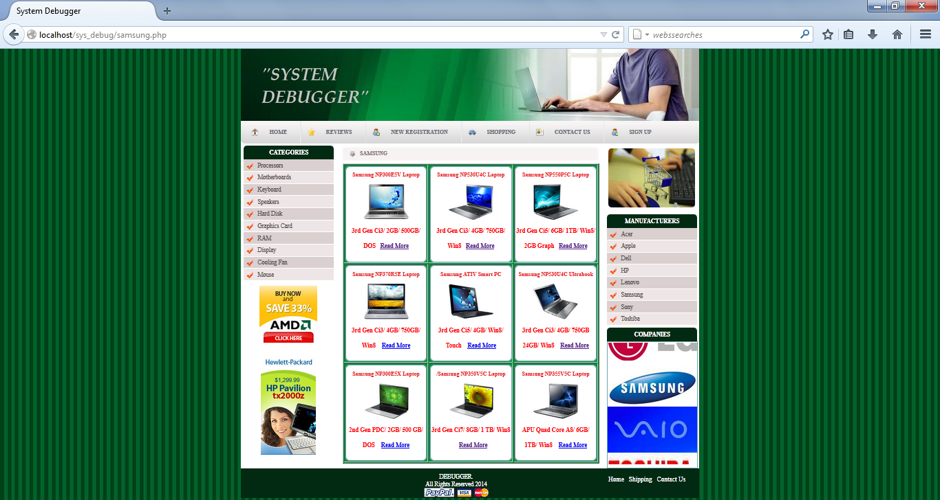

Figure 5.30 Samsung Page

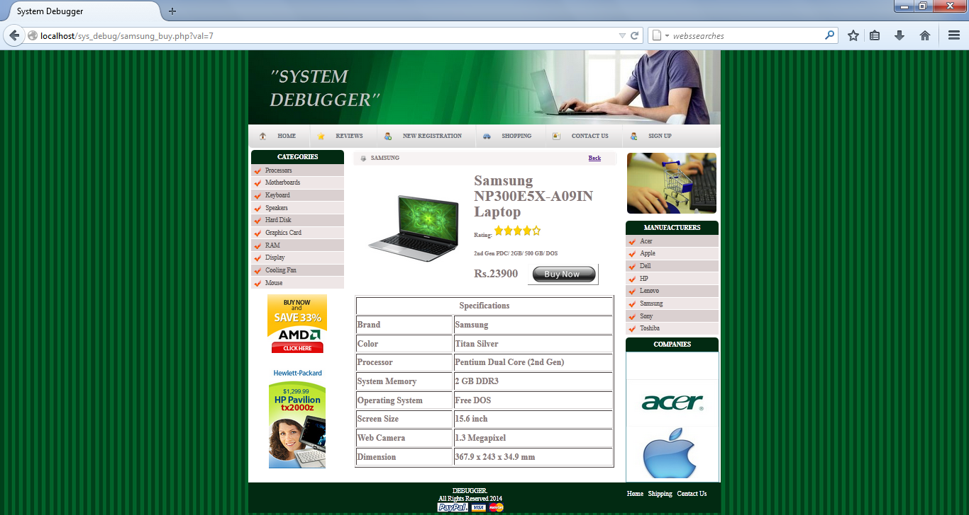

Figure 5.31 Samsung Details Page

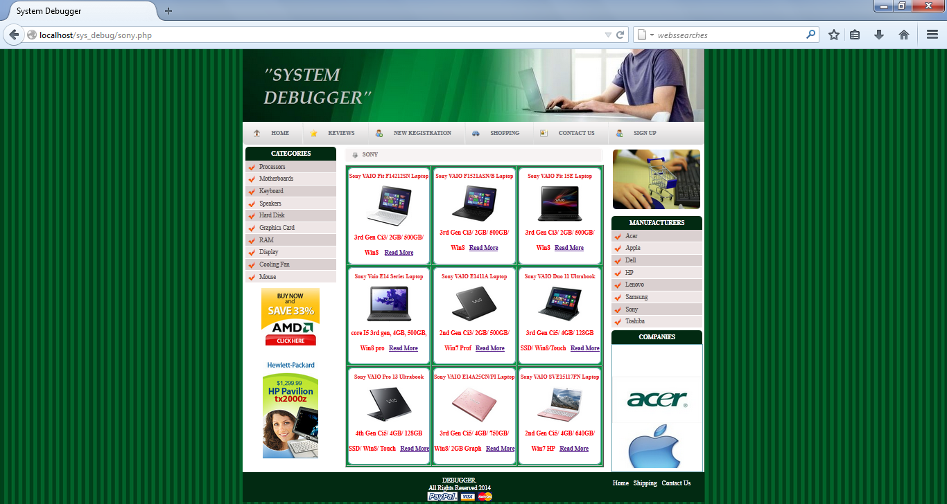

Figure 5.32 Sony Page

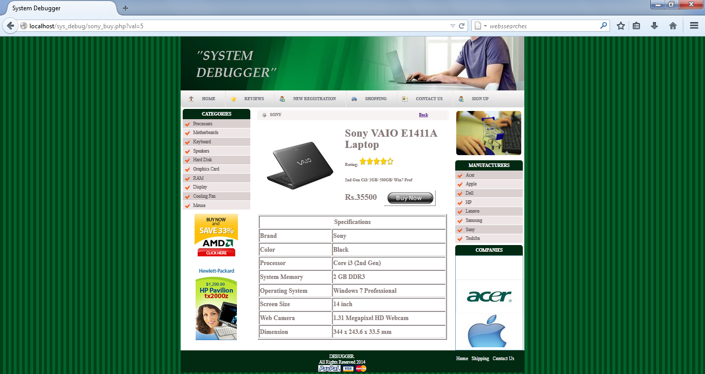

Figure 5.33 Sony Details Page

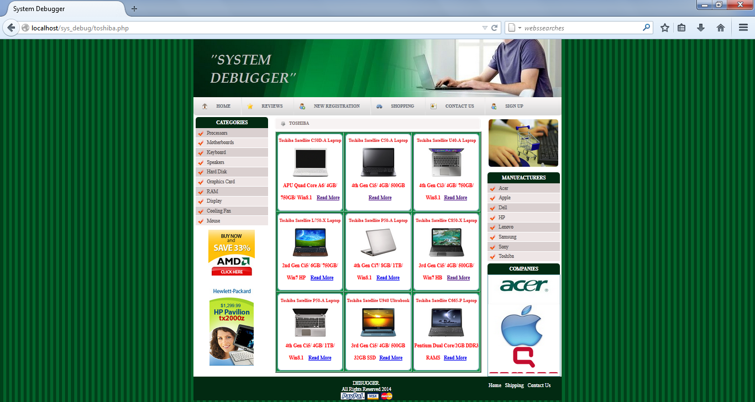

Figure 5.34Toshiba Page

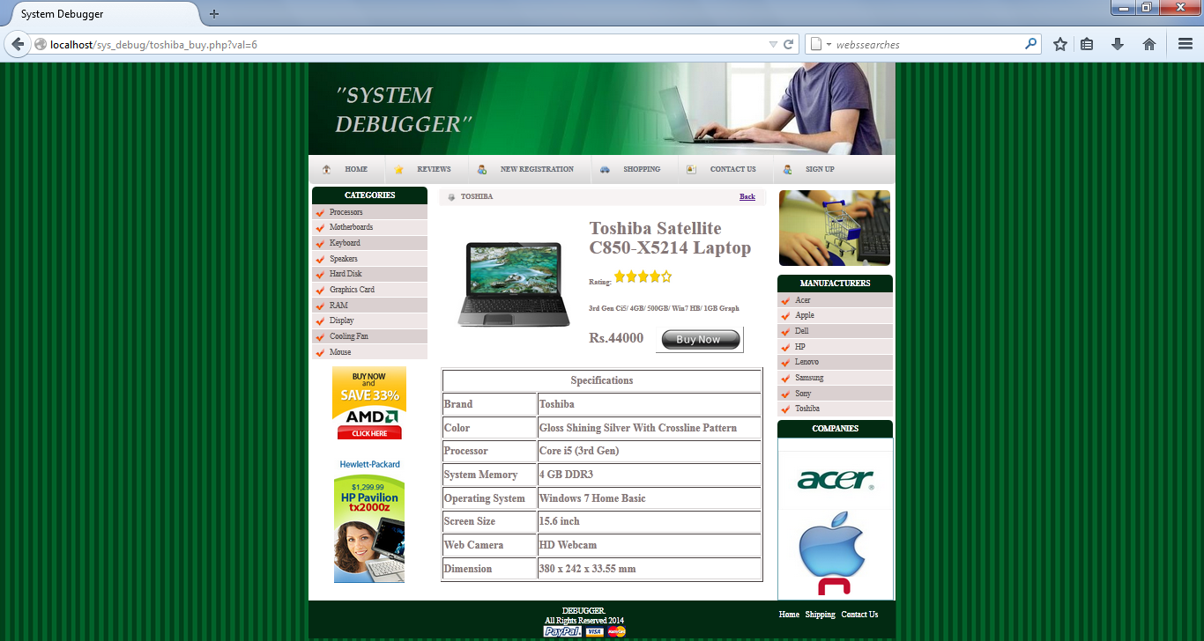

Figure 5.35Toshiba Detail Page

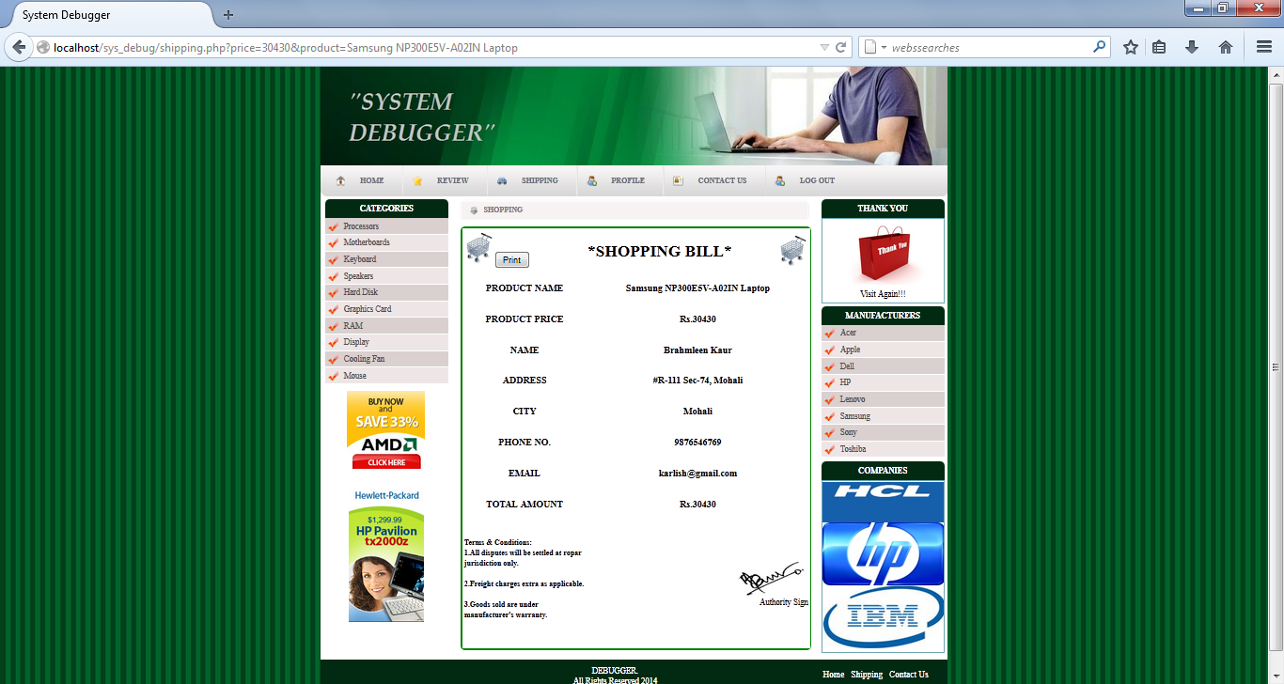

Figure 5.36 Shopping Bill Page

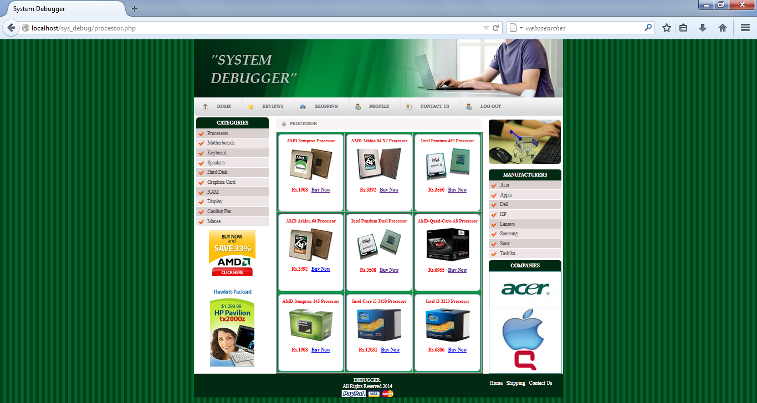

Figure 5.37 Processors Page

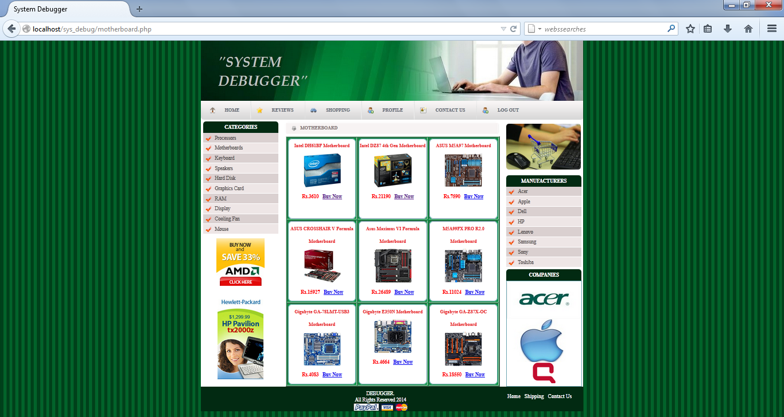

Figure 5.38 Motherboard Page

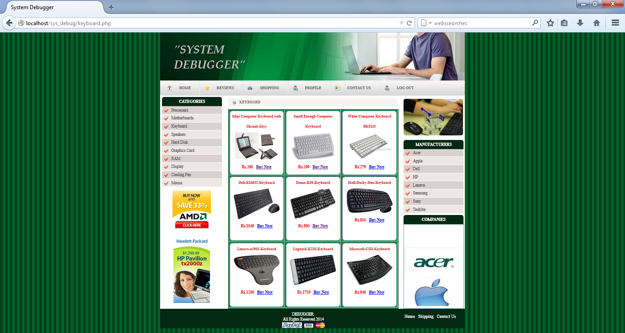

Figure 5.39 Keyboard Page

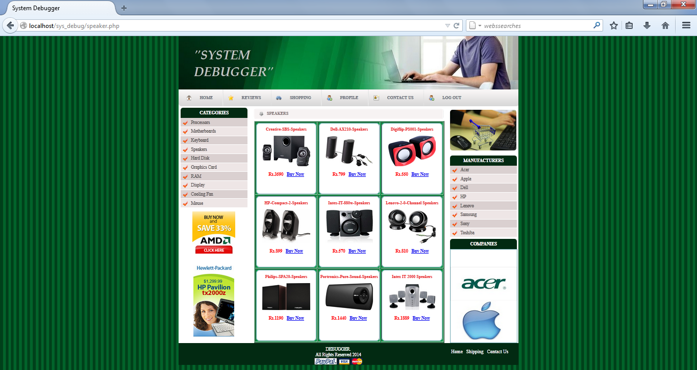

Figure 5.40 Speakers Page

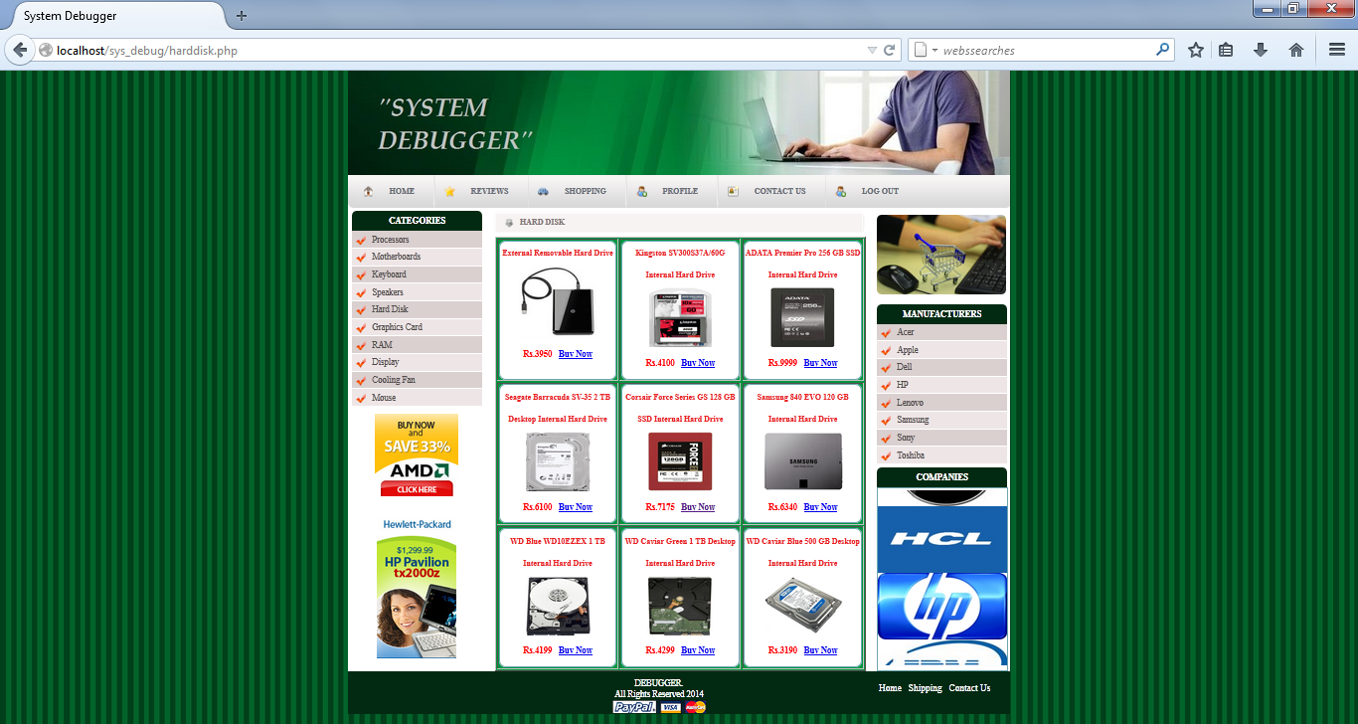

Figure 5.41Hard Disk Page

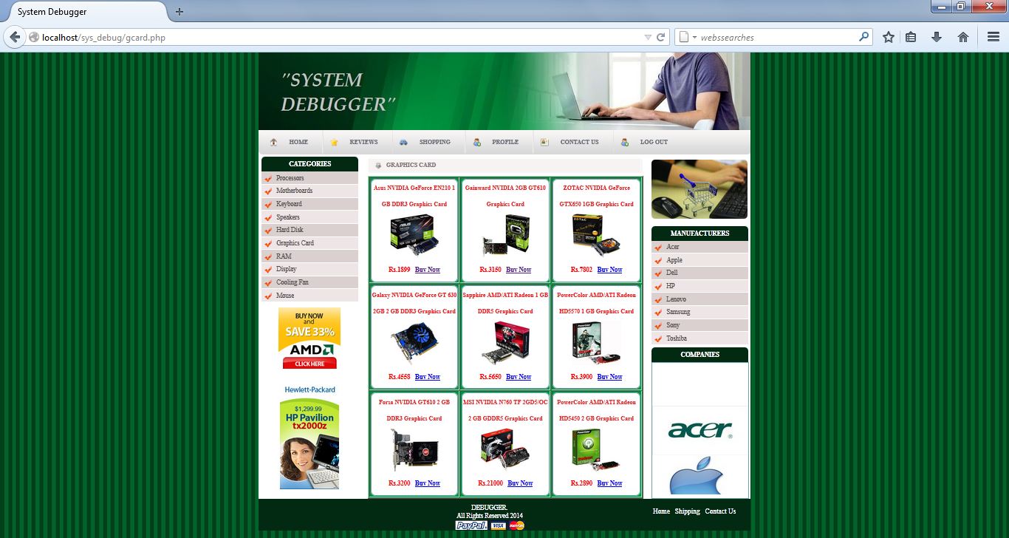

Figure 5.42 Graphics Card Page

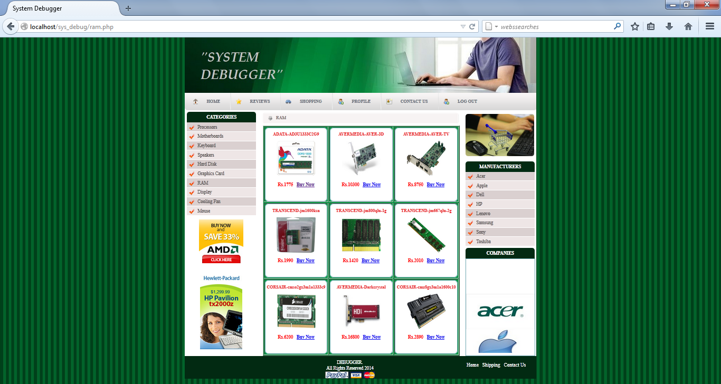

Figure 5.43 RAM Page

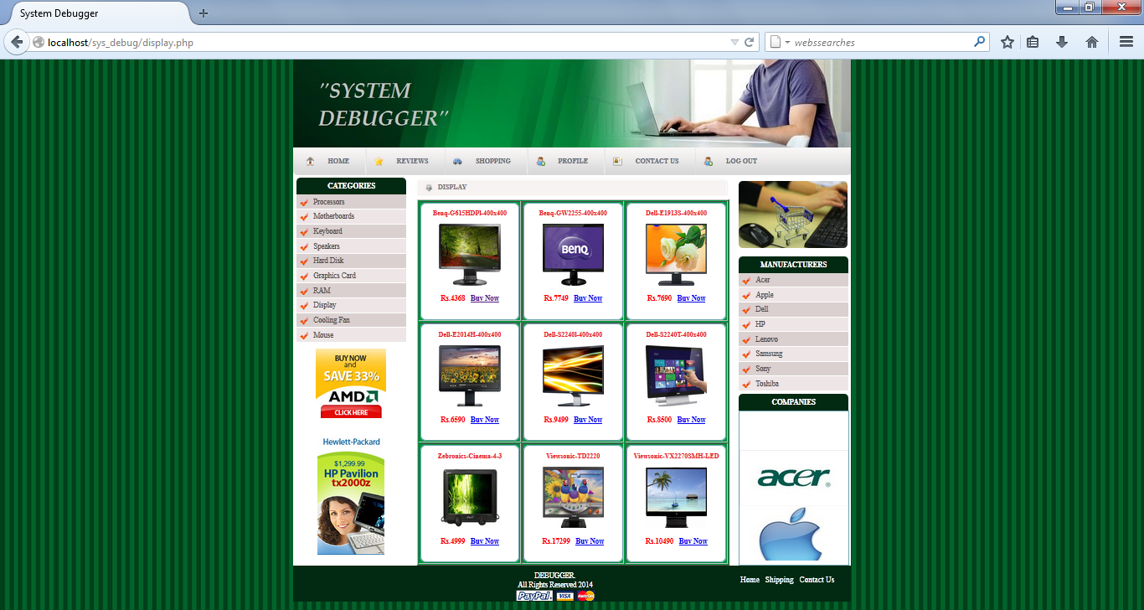

Figure 5.44 Display Page

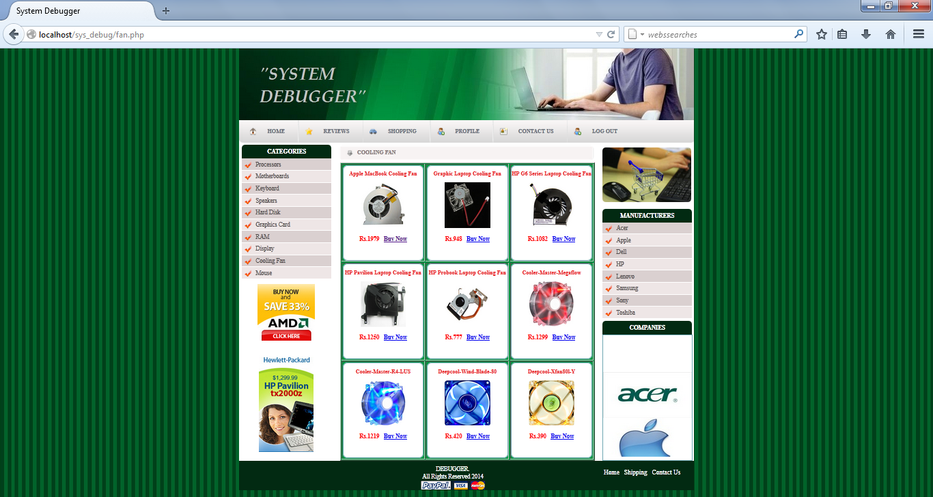

Figure 5.45 Cooling Fan Page

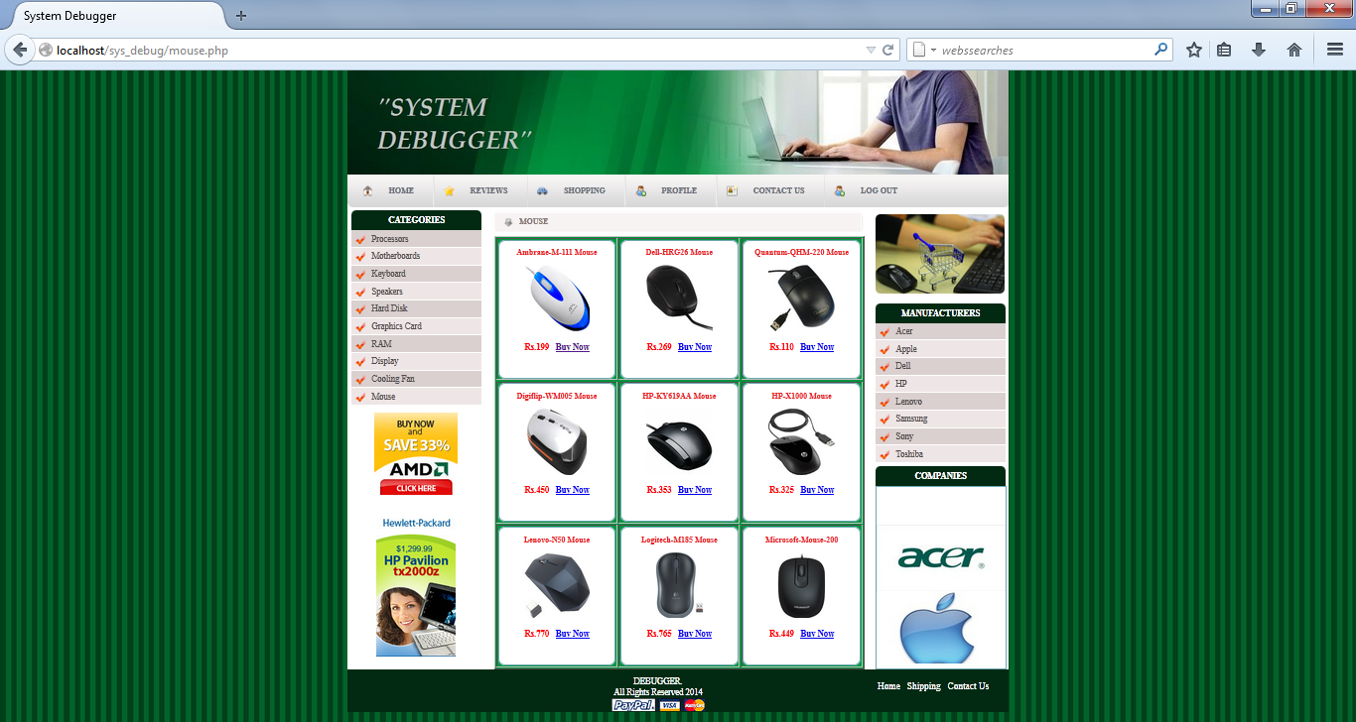

Figure 5.46 Mouse Page

**Home Page Coding**

<?php

if(isset($_GET['msgd'])==3)

{

echo"<script>alert('Please LOGIN First')</script>";

}

?>

<!DOCTYPE html PUBLIC "-//W3C//DTD XHTML 1.0 Transitional//EN" "http://www.w3.org/TR/xhtml1/DTD/xhtml1-transitional.dtd">

<html xmlns="http://www.w3.org/1999/xhtml">

<head>

<meta http-equiv="Content-Type" content="text/html; charset=windows-1252" />

<title>System Debugger</title>

<link rel="stylesheet" type="text/css" href="style.css" />

<!--[if IE 6]>

<link rel="stylesheet" type="text/css" href="iecss.css" />

<![endif]-->

<script type="text/javascript" src="js/boxOver.js"></script>

</head>

<body>

<div id="main_container">

<div id="header"></div>

<!-- end of oferte_content-->

<div id="main_content">

<div id="menu_tab">

<div class="left_menu_corner"></div>

<ul class="menu">

<li><a href="index.php" class="nav1">HOME</a></li>

<li class="divider"></li>

<li><a href="reviews.php" class="nav3">REVIEWS</a></li>

<li class="divider"></li>

<li><a href="register.php" class="nav4">NEW REGISTRATION</a></li>

<li class="divider"></li>

<li><a href="acer.php" class="nav5">SHOPPING</a></li>

<li class="divider"></li>

<li><a href="contact.php" class="nav6">CONTACT US</a></li>

<li class="divider"></li>

<li><a href="register.php" class="nav4">SIGN UP</a></li>

</ul>

<div class="right_menu_corner"></div>

</div>

<!-- end of menu tab -->

<div class="left_content">

<div class="title_box">CATEGORIES</div>

<ul class="left_menu">

<?php

include("categories.php");

?>

</ul>

<div class="banner_adds"><a href="#"><imgsrc="images/bann2.jpg" alt="" title="" border="0" /></a></div>

<div class="banner_adds"><a href="#"><imgsrc="images/Anti Virus Poster.jpeg" height="250px" width="160px" /></a></div>

</div>

<!-- end of left content -->

<div class="center_content">

<?php

$result="";

if(isset($_GET['msgreg']))

{

$result="";

$result="...Congrats!!";

}?>

<div class="center_title_bar">SYSTEM DEBUGGER <?php echo $result;?></div>

<div class="prod_box_big">

<div class="center_prod_box_big">

<div class="img"><imgsrc="images/logo1.jpg" width="518" height="209" /></div>

<div class="text"><font style="box-decoration-break:!important" size="3">

<h3>

<p style="display:block;background:url(images/checked.png) no-repeat left; background-position:5px 5px;padding:0 0 0 30px">

System Debugger is introduced to develop hardware fault detection for any computer system.

</p>

<p style="display:block;background:url(images/checked.png) no-repeat left; background-position:5px 5px;padding:0 0 0 30px">

Different hardware system or electronics devices usually face application fault as well as hardware fault.

</p>

<p style="display:block;background:url(images/checked.png) no-repeat left; background-position:5px 5px;padding:0 0 0 30px">

This application oriented formal reasoning applies to determine the problem in computer system.

</p>

<p style="display:block;background:url(images/checked.png) no-repeat left; background-position:5px 5px;padding:0 0 0 30px">

Through Debugger we can solve our problems and we can also buy laptops, destops, etc by login into it easily.</p>

<p style="display:block;background:url(images/checked.png) no-repeat left; background-position:5px 5px;padding:0 0 0 30px">

It proposes lot of new technological changes and inclusion to make the system more perfective and efficient data handler.

</p>

<p style="display:block;background:url(images/checked.png) no-repeat left; background-position:5px 5px;padding:0 0 0 30px">

This guide provides helpful hints and solutions for troubleshooting the products as well as shopping for those hardware componets which are defected in our computer system.

</p>

</h3>

</font></div>

</div>

</div>

</div>

<!-- end of center content -->

<div class="right_content">

<div class="title_box">LOGIN</div>

<div class="border_box">

<form name="fsignin" onsubmit="signin()" action="login_trans.php" method="post">

<table bgcolor="#FFFFFF">

<tr>

<td>Username: </td>

<td align="left"><input type="text" name="uname" style="width:115px"/></td>

</tr>

<tr>

<td>Password: </td>

<td align="left"><input type="password" name="pswd" style="width:115px"/></td>

</tr>

<tr>

<td align="center" colspan="2"><input type="submit" value="LOGIN"/></td>

</tr>

<tr>

<td colspan="2" align="center"><a href="register.php">Click here to register</a></td>

</tr>

</table>

</form>

</div>

<div class="title_box">MANUFACTURERS</div>

<?php

include("manufacture.php");

?>

<div class="title_box">COMPANIES</div>

<div class="border_box">

<div class="product_img">

<marquee height="280px" direction="up" bgcolor="#FFFFFF" style="margin-bottom:5px">

<imgsrc="images/logo/acer_logo.jpg" width="194" height="100" />

<imgsrc="images/logo/apple-logo.jpg" width="194" height="114" />

<imgsrc="images/logo/Compaq_logo.png" width="194" height="100" />

<imgsrc="images/logo/dell-logo.jpg" width="194" height="100" />

<imgsrc="images/logo/hcl_logo.jpg" width="194" height="100" />

<imgsrc="images/logo/HP-Logo.jpg" width="194" height="100" />

<imgsrc="images/logo/IBM-Logo.jpg" width="194" height="100" />

<imgsrc="images/logo/lenovo-logo.jpg" width="194" height="100" />

<imgsrc="images/logo/lg_logo.jpg" width="194" height="100" />

<imgsrc="images/logo/Samsung_logo.jpg" width="194" height="100" />

<imgsrc="images/logo/sony_logo.jpg" width="194" height="100" />

<imgsrc="images/logo/toshiba_logo.jpg" width="194" height="100" />

</marquee>

</div>

</div>

</div>

<!-- end of right content -->

</div>

<!-- end of main content -->

<?php

include("footer.php");

?>

<!-- end of main_container -->

</body>

</html>

Login Page

<!DOCTYPE html PUBLIC "-//W3C//DTD XHTML 1.0 Transitional//EN" "http://www.w3.org/TR/xhtml1/DTD/xhtml1-transitional.dtd">

<html xmlns="http://www.w3.org/1999/xhtml">

<head>

<meta http-equiv="Content-Type" content="text/html; charset=windows-1252" />

<title>System Debugger</title>

<link rel="stylesheet" type="text/css" href="style.css" />

<!--[if IE 6]>

<link rel="stylesheet" type="text/css" href="iecss.css" />

<![endif]-->

<script type="text/javascript" src="js/boxOver.js"></script>

</head>

<body>

<div id="main_container">

<div class="top_bar"></div>

<div id="header"></div>

<!-- end of oferte_content-->

<div id="main_content">

<div id="menu_tab">

<div class="left_menu_corner"></div>

<ul class="menu">

<li><a href="index.php" class="nav1">HOME</a></li>

<li class="divider"></li>

<li><a href="reviews.php" class="nav3">REVIEWS</a></li>

<li class="divider"></li>

<li><a href="register.php" class="nav4">NEW REGISTRATION</a></li>

<li class="divider"></li>

<li><a href="acer.php" class="nav5">SHOPPING</a></li>

<li class="divider"></li>

<li><a href="contact.php" class="nav6">CONTACT US</a></li>

<li class="divider"></li>

<li><a href="register.php" class="nav4">SIGN UP</a></li>

</ul>

<div class="right_menu_corner"></div>

</div>

<!-- end of menu tab -->

<div class="left_content">

<div class="title_box">Categories</div>

<ul class="left_menu">

<?php

include("categories.php");

?>

</ul>

<div class="banner_adds"><a href="#"><imgsrc="images/bann2.jpg" alt="" title="" border="0" /></a></div>

<div class="banner_adds"><a href="#"><imgsrc="images/bann1.jpg" alt="" title="" border="0" /></a></div>

</div>

<!-- end of left content -->

<div class="center_content">

<div class="center_title_bar">LOGIN

<div class="login" align="left" margin_left="0px">

<form name="fsignin" onsubmit="signin()" action="login1.php" method="post">

<table bgcolor="#DAD0D0" height="400px" width="450px" align="center">

<tr>

<td><h2>Username: </h2></td>

<td align="left"><input type="text" name="uname" style="width:127px"/></td>

</tr>

<tr>

<td><h2>Password: </h2></td>

<td align="left"><input type="password" name="pswd" style="width:127px"/></td>

</tr>

<tr>

<td align="center" colspan="2"><input type="submit" value="LOGIN"/></td>

</tr>

<tr>

<td colspan="2"><a href="register.php">Click here to register</a></td>

</tr>

</table>

</form>

</div>

</div>

</div>

<!-- end of center content -->

<div class="right_content">

<div class="title_box">Manufacturers</div>

<?php

include("manufacture.php");

?>

<div class="title_box">Companies</div>

<div class="border_box">

<div class="product_img">

<?php

include("marquee.php");

?>

</div>

</div>

</div>

<!-- end of right content -->

</div>

<!-- end of main content -->

<?php

include("footer.php");

?>

<!-- end of main_container -->

</body>

</html>

Product Buy Page

<!DOCTYPE html PUBLIC "-//W3C//DTD XHTML 1.0 Transitional//EN" "http://www.w3.org/TR/xhtml1/DTD/xhtml1-transitional.dtd">

<html xmlns="http://www.w3.org/1999/xhtml">

<head>

<meta http-equiv="Content-Type" content="text/html; charset=windows-1252" />

<title>System Debugger</title>

<link rel="stylesheet" type="text/css" href="style.css" />

<!--[if IE 6]>

<link rel="stylesheet" type="text/css" href="iecss.css" />

<![endif]-->

<script type="text/javascript" src="js/boxOver.js"></script>

</head>

<body>

<div id="main_container">

<div id="header"></div>

<!-- end of oferte_content-->

<div id="main_content">

<div id="menu_tab">

<div class="left_menu_corner"></div>

<ul class="menu">

<li><a href="index.php" class="nav1">HOME</a></li>

<li class="divider"></li>

<li><a href="reviews.php" class="nav3">REVIEWS</a></li>

<li class="divider"></li>

<li><a href="register.php" class="nav4">NEW REGISTRATION</a></li>

<li class="divider"></li>

<li><a href="#" class="nav5">SHOPPING</a></li>

<li class="divider"></li>

<li><a href="contact.php" class="nav6">CONTACT US</a></li>

<li class="divider"></li>

<li><a href="#" class="nav4">SIGN UP</a></li>

</ul>

<div class="right_menu_corner"></div>

</div>

<!-- end of menu tab -->

<div class="left_content">

<div class="title_box">CATEGORIES</div>

<ul class="left_menu">

<?php

include("categories.php")

?>

</ul>

<div class="banner_adds"><a href="#"><imgsrc="images/bann2.jpg" alt="" title="" border="0" /></a></div>

<div class="banner_adds"><a href="#"><imgsrc="images/bann1.jpg" alt="" title="" border="0" /></a></div>

</div>

<!-- end of left content -->

<?php

$id=$_REQUEST['val'];

if($id=='1')

{

?>

<div class="center_content">

<div class="center_title_bar">APPLE<font style="margin-left:420px;"><a href="apple.php">Back</a></font>

<div class="apple_m" align="left" margin_left="0px">

<form action="" method="post" >

<table height="650px" width="555px" border="0" bgcolor="#fff" align="center" style="border-radius:10px 10px 10px 10px">

<tr>

<td height="250px" width="250px" align="center"><imgsrc="images/apple/Apple_ME665HN_MacBook _Pro.jpg" width="200" height="150"/></td>

<td><table height="250" width="300" align="center">

<tr>

<td><font size="+3">Apple ME665HN/A MacBook Pro</font></td>

</tr>

<tr>

<td>Rating: <imgsrc="image/stars1.jpg" width="100" height="30" /></td>

</tr>

<tr>

<td>3rd Gen Ci7/ 16GB/ 512GB Flash/ Mac OS X Mountain Lion/ 1GB Graph/ Retina Display</td>

</tr>

<tr>

<td><font size="+2">Rs.179900</font>&nbsp; &nbsp; &nbsp;

<a href="shipping.php?price=179900&product=Apple ME665HN/A MacBook Pro">

<input type="button" value="" style="background:url(images/buy.png); height:45px; width:150px" />

</a></td>

</tr>

</table></td>

</tr>

<tr>

<td colspan="2"><table border="1" width="550px" style="font-size:18px">

<tr>

<td colspan="2" align="center">Specifications</td>

</tr>

<tr>

<td>Brand</td>

<td>Apple</td>

</tr>

<tr>

<td>Color</td>

<td>Silver</td>

</tr>

<tr>

<td>Processor</td>

<td>Intel-Core i7 (2nd Generation)</td>

</tr>

<tr>

<td>System Memory</td>

<td>16 GB DDR3</td>

</tr>

<tr>

<td>Operating System</td>

<td>Mac OS X Mountain Lion</td>

</tr>

<tr>

<td>Screen Size</td>

<td>15 inch</td>

</tr>

<tr>

<td>Web Camera</td>

<td>720p FaceTime HD Webcam</td>

</tr>

<tr>

<td>Dimension</td>

<td>358.9 x 247.1 x 18 mm</td>

</tr>

</table></td>

</tr>

</table>

</form>

</div>

</div>

</div>

<?php }

if($id=='2')

{

?>

<div class="center_content">

<div class="center_title_bar">APPLE<font style="margin-left:420px;"><a href="apple.php">Back</a></font>

<div class="apple_m" align="left" margin_left="0px">

<form action="" method="post" >

<table height="650px" width="555px" border="0" bgcolor="#fff" align="center" style="border-radius:10px 10px 10px 10px">

<tr>

<td height="250px" width="250px" align="center"><imgsrc="images/apple/Apple_ME665HN_MacBook _Pro.jpg" width="200" height="150"/></td>

<td><table height="250" width="300" align="center">

<tr>

<td><font size="+3">Apple MD761HN/A MacBook Air</font></td>

</tr>

<tr>

<td>Rating: <imgsrc="images/stars1.jpg" width="100" height="30" /></td>

</tr>

<tr>

<td>4th Gen Ci5/ 4GB/ 256GB Flash/ Mac OS X Mountain Lion</td>

</tr>

<tr>

<td><font size="+2">Rs.170000</font>&nbsp; &nbsp; &nbsp;

<a href="shipping.php?price=170000&product=Apple MD761HN/A MacBook Air"><imgsrc="images/buy.png" width="150" height="45" />

</a></td>

</tr>

</table></td>

</tr>

<tr>

<td colspan="2"><table border="1" width="550px" style="font-size:18px">

<tr>

<td colspan="2" align="center">Specifications</td>

</tr>

<tr>

<td>Brand</td>

<td>Apple</td>

</tr>

<tr>

<td>Color</td>

<td>Silver</td>

</tr>

<tr>

<td>Processor</td>

<td>Intel-Core i5 (4th Generation)</td>

</tr>

<tr>

<td>System Memory</td>

<td>4 GB DDR3</td>

</tr>

<tr>

<td>Operating System</td>

<td>Mac OS X Mountain Lion</td>

</tr>

<tr>

<td>Screen Size</td>

<td>13 inch</td>

</tr>

<tr>

<td>Web Camera</td>

<td>720p FaceTime HD Webcam</td>

</tr>

<tr>

<td>Dimension</td>

<td>325 x 227 x 17 mm</td>

</tr>

</table></td>

</tr>

</table>

</form>

</div>

</div>

</div>

<?php }

if($id=='3')

{

?>

<div class="center_content">

<div class="center_title_bar">APPLE<font style="margin-left:420px;"><a href="apple.php">Back</a></font>

<div class="apple_m" align="left" margin_left="0px">

<form action="" method="post" >

<table height="650px" width="555px" border="0" bgcolor="#fff" align="center" style="border-radius:10px 10px 10px 10px">

<tr>

<td height="250px" width="250px" align="center"><imgsrc="images/apple/Apple iMac ME086B.jpg" width="200" height="150"/></td>

<td><table height="250" width="300" align="center">

<tr>

<td><font size="+3">Apple iMac ME086B</font></td>

</tr>

<tr>

<td>Rating: <imgsrc="images/stars1.jpg" width="100" height="30" /></td>

</tr>

<tr>

<td>Intel Core i5, 8GB RAM, 1TB, 21.5</td>

</tr>

<tr>

<td><font size="+2">Rs.50000</font>&nbsp; &nbsp; &nbsp;

<a href="shipping.php?price=50000&product=Apple iMac ME086B">

<input type="button" value="" style="background:url(images/buy.png); height:45px; width:150px" />

</a></td>

</tr>

</table></td>

</tr>

<tr>

<td colspan="2"><table border="1" width="550px" style="font-size:18px">

<tr>

<td colspan="2" align="center">Specifications</td>

</tr>

<tr>

<td>Brand</td>

<td>Apple</td>

</tr>

<tr>

<td>Color</td>

<td>Black</td>

</tr>

<tr>

<td>Processor</td>

<td>Intel-Core i5 (2nd Generation)</td>

</tr>

<tr>

<td>System Memory</td>

<td>8 GB DDR3</td>

</tr>

<tr>

<td>Operating System</td>

<td>Mac OS X Mountain Lion</td>

</tr>

<tr>

<td>Screen Size</td>

<td>21.5 inch</td>

</tr>

<tr>

<td>Web Camera</td>

<td>650p FaceTime HD Webcam</td>

</tr>

<tr>

<td>Dimension</td>

<td>350 x 220 x 18 mm</td>

</tr>

</table></td>

</tr>

</table>

</form>

</div>

</div>

</div>

<?php }

if($id=='4')

{

?>

<div class="center_content">

<div class="center_title_bar">APPLE<font style="margin-left:420px;"><a href="apple.php">Back</a></font>

<div class="apple_m" align="left" margin_left="0px">

<form action="" method="post" >

<table height="650px" width="555px" border="0" bgcolor="#fff" align="center" style="border-radius:10px 10px 10px 10px">

<tr>

<td height="250px" width="250px" align="center"><imgsrc="images/apple/Apple Mac Mini MD387B.png" width="200" height="150"/></td>

<td><table height="250" width="300" align="center">

<tr>

<td><font size="+3">Apple Mac Mini MD387B</font></td>

</tr>

<tr>

<td>Rating: <imgsrc="images/stars1.jpg" width="100" height="30" /></td>

</tr>

<tr>

<td>Intel Core i5, 4GB </td>

</tr>

<tr>

<td><font size="+2">Rs.57500</font>&nbsp; &nbsp; &nbsp;

<a href="shipping.php?price=57500&product=Apple Mac Mini MD387B">

<input type="button" value="" style="background:url(images/buy.png); height:45px; width:150px" />

</a></td>

</tr>

</table></td>

</tr>

<tr>

<td colspan="2"><table border="1" width="550px" style="font-size:18px">

<tr>

<td colspan="2" align="center">Specifications</td>

</tr>

<tr>

<td>Brand</td>

<td>Apple</td>

</tr>

<tr>

<td>Color</td>

<td>white</td>

</tr>

<tr>

<td>Processor</td>

<td>Intel-Core i5(Desktop computer)</td>

</tr>

<tr>

<td>System Memory</td>

<td>4 GB</td>

</tr>

<tr>

<td>Operating System</td>

<td>Mac OS X Mountain Lion</td>

</tr>

<tr>

<td>Screen Size</td>

<td>21 inch</td>

</tr>

<tr>

<td>Dimension</td>

<td>358.9 x 247.1 x 18 mm</td>

</tr>

</table></td>

</tr>

</table>

</form>

</div>

</div>

</div>

<?php }

if($id=='5')

{

?>

<div class="center_content">

<div class="center_title_bar">APPLE<font style="margin-left:420px;"><a href="apple.php">Back</a></font>

<div class="apple_m" align="left" margin_left="0px">

<form action="" method="post" >

<table height="650px" width="555px" border="0" bgcolor="#fff" align="center" style="border-radius:10px 10px 10px 10px">

<tr>

<td height="250px" width="250px" align="center"><imgsrc="images/apple/Apple_MD761HN_MacBook_Air.jpg" width="200" height="150"/></td>

<td><table height="250" width="300" align="center">

<tr>

<td><font size="+3">Apple MacBook Air, MD712B</font></td>

</tr>

<tr>

<td>Rating: <imgsrc="images/stars1.jpg" width="100" height="30" /></td>

</tr>

<tr>

<td>Intel Core i5, 256GB Flash, 4GB </td>

</tr>

<tr>

<td><font size="+2">Rs.129000</font>&nbsp; &nbsp; &nbsp;

<a href="shipping.php?price=129000&product=Apple MacBook Air, MD712B">

<input type="button" value="" style="background:url(images/buy.png); height:45px; width:150px" />

</a></td>

</tr>

</table></td>

</tr>

<tr>

<td colspan="2"><table border="1" width="550px" style="font-size:18px">

<tr>

<td colspan="2" align="center">Specifications</td>

</tr>

<tr>

<td>Brand</td>

<td>Apple</td>

</tr>

<tr>

<td>Color</td>

<td>Grey</td>

</tr>

<tr>

<td>Processor</td>

<td>Intel-Core i5 (2nd Generation)</td>

</tr>

<tr>

<td>System Memory</td>

<td> 256GB Flash</td>

</tr>

<tr>

<td>Operating System</td>

<td>Mac OS X Mountain Lion</td>

</tr>

<tr>

<td>Screen Size</td>

<td>17 inch</td>

</tr>

<tr>

<td>Web Camera</td>

<td>720p FaceTime HD Webcam</td>

</tr>

<tr>

<td>Dimension</td>

<td>358.9 x 247.1 x 18 mm</td>

</tr>

</table></td>

</tr>

</table>

</form>

</div>

</div>

</div>

<?php }

if($id=='6')

{

?>

<div class="center_content">

<div class="center_title_bar">APPLE<font style="margin-left:420px;"><a href="apple.php">Back</a></font>

<div class="apple_m" align="left" margin_left="0px">

<form action="" method="post" >

<table height="650px" width="555px" border="0" bgcolor="#fff" align="center" style="border-radius:10px 10px 10px 10px">

<tr>

<td height="250px" width="250px" align="center"><imgsrc="images/apple/Apple MacBook Pro Mac MD101HN Laptop.jpg" width="200" height="150"/></td>

<td><table height="250" width="300" align="center">

<tr>

<td><font size="+3">Apple MacBook Pro Mac Laptop</font></td>

</tr>

<tr>

<td>Rating: <imgsrc="images/stars1.jpg" width="100" height="30" /></td>

</tr>

<tr>

<td>Core i5/4 GB DDR3 RAM/500 GB HDD/Mac OS</td>

</tr>

<tr>

<td><font size="+2">Rs.76299</font>&nbsp; &nbsp; &nbsp;

<a href="shipping.php?price=76299&product=Apple MacBook Pro Mac Laptop">

<input type="button" value="" style="background:url(images/buy.png); height:45px; width:150px" />

</a></td>

</tr>

</table></td>

</tr>

<tr>

<td colspan="2"><table border="1" width="550px" style="font-size:18px">

<tr>

<td colspan="2" align="center">Specifications</td>

</tr>

<tr>

<td>Brand</td>

<td>Apple</td>

</tr>

<tr>

<td>Color</td>

<td>Silver</td>

</tr>

<tr>

<td>Processor</td>

<td>Core i5 (2nd Generation)</td>

</tr>

<tr>

<td>System Memory</td>

<td>4 GB DDR3</td>

</tr>

<tr>

<td>Operating System</td>

<td>Mac OS X Lion</td>

</tr>

<tr>

<td>Screen Size</td>

<td>13 inch</td>

</tr>

<tr>

<td>Web Camera</td>

<td>720p FaceTime HD Webcam</td>

</tr>

<tr>

<td>Dimension</td>

<td>314 x 219 x 19 mm</td>

</tr>

</table></td>

</tr>

</table>

</form>

</div>

</div>

</div>

<?php }

if($id=='7')

{

?>

<div class="center_content">

<div class="center_title_bar">APPLE<font style="margin-left:420px;"><a href="apple.php">Back</a></font>

<div class="apple_m" align="left" margin_left="0px">

<form action="" method="post" >

<table height="650px" width="555px" border="0" bgcolor="#fff" align="center" style="border-radius:10px 10px 10px 10px">

<tr>

<td height="250px" width="250px" align="center"><imgsrc="images/apple/Apple MD712HN MacBook Air.jpg" width="200" height="150"/></td>

<td><table height="250" width="300" align="center">

<tr>

<td><font size="+3">Apple MD712HN/A MacBook Air</font></td>

</tr>

<tr>

<td>Rating: <imgsrc="images/stars1.jpg" width="100" height="30" /></td>

</tr>

<tr>

<td>4th Gen Ci5/ 4GB/ 256GB Flash/ Mac OS X Mountain Lion</td>

</tr>

<tr>

<td><font size="+2">Rs.72000</font>&nbsp; &nbsp; &nbsp;

<a href="shipping.php?price=72000&product=Apple MD712HN/A MacBook Air">

<input type="button" value="" style="background:url(images/buy.png); height:45px; width:150px" />

</a></td>

</tr>

</table></td>

</tr>

<tr>

<td colspan="2"><table border="1" width="550px" style="font-size:18px">

<tr>

<td colspan="2" align="center">Specifications</td>

</tr>

<tr>

<td>Brand</td>

<td>Apple</td>

</tr>

<tr>

<td>Color</td>

<td>Silver</td>

</tr>

<tr>

<td>Processor</td>

<td>Intel-Core i5 (4th Generation)</td>

</tr>

<tr>

<td>System Memory</td>

<td>4 GB DDR3</td>

</tr>

<tr>

<td>Operating System</td>

<td>Mac OS X Mountain Lion</td>

</tr>

<tr>

<td>Screen Size</td>

<td>11 inch</td>

</tr>

<tr>

<td>Web Camera</td>

<td>720p FaceTime HD Webcam</td>

</tr>

<tr>

<td>Dimension</td>

<td>300 x 192 x 17 mm</td>

</tr>

</table></td>

</tr>

</table>

</form>

</div>

</div>

</div>

<?php }

if($id=='8')

{

?>

<div class="center_content">

<div class="center_title_bar">APPLE<font style="margin-left:420px;"><a href="apple.php">Back</a></font>

<div class="apple_m" align="left" margin_left="0px">

<form action="" method="post" >

<table height="650px" width="555px" border="0" bgcolor="#fff" align="center" style="border-radius:10px 10px 10px 10px">

<tr>

<td height="250px" width="250px" align="center"><imgsrc="images/apple/Apple Macbook Pro Laptop.jpg" width="200" height="150"/></td>

<td><table height="250" width="300" align="center">

<tr>

<td><font size="+3">Apple Macbook Pro Laptop</font></td>

</tr>

<tr>

<td>Rating: <imgsrc="images/stars1.jpg" width="100" height="30" /></td>

</tr>

<tr>

<td>Core i5 (4th Gen)/8 GB DDR3 RAM/256 GB HDD/Mac OS X Mavericks</td>

</tr>

<tr>

<td><font size="+2">Rs.114900</font>&nbsp; &nbsp; &nbsp;

<a href="shipping.php?price=114900&product=Apple Macbook Pro Laptop">

<input type="button" value="" style="background:url(images/buy.png); height:45px; width:150px" />

</a></td>

</tr>

</table></td>

</tr>

<tr>

<td colspan="2"><table border="1" width="550px" style="font-size:18px">

<tr>

<td colspan="2" align="center">Specifications</td>

</tr>

<tr>

<td>Brand</td>

<td>Apple</td>

</tr>

<tr>

<td>Color</td>

<td>Silver</td>

</tr>

<tr>

<td>Processor</td>

<td>Intel-Core i5 (4th Generation)</td>

</tr>

<tr>

<td>System Memory</td>

<td>8 GB DDR3</td>

</tr>

<tr>

<td>Operating System</td>

<td>Mac OS X Mavericks</td>

</tr>

<tr>

<td>Screen Size</td>

<td>13.3 inch</td>

</tr>

<tr>

<td>Web Camera</td>

<td>720p FaceTime HD Webcam</td>

</tr>

<tr>

<td>Dimension</td>

<td>358.9 x 245 x 18 mm</td>

</tr>

</table></td>

</tr>

</table>

</form>

</div>

</div>

</div>

<?php }

if($id=='9')

{

?>

<div class="center_content">

<div class="center_title_bar">APPLE<font style="margin-left:420px;"><a href="apple.php">Back</a></font>

<div class="apple_m" align="left" margin_left="0px">

<form action="" method="post" >

<table height="650px" width="555px" border="0" bgcolor="#fff" align="center" style="border-radius:10px 10px 10px 10px">

<tr>

<td height="250px" width="250px" align="center"><imgsrc="images/apple/Apple MD102HN MacBook Pro.jpg" width="200" height="150"/></td>

<td><table height="250" width="300" align="center">

<tr>

<td><font size="+3">Apple MD102HN/A MacBook Pro</font></td>

</tr>

<tr>

<td>Rating: <imgsrc="images/stars1.jpg" width="100" height="30" /></td>

</tr>

<tr>

<td>3rd Gen Ci7/ 8GB/ 750GB/ Mac OS X Mountain Lion</td>

</tr>

<tr>

<td><font size="+2">Rs.99600</font>&nbsp; &nbsp; &nbsp;

<a href="shipping.php?price=99600&product=Apple MD102HN/A MacBook Pro">

<input type="button" value="" style="background:url(images/buy.png); height:45px; width:150px" />

</a></td>

</tr>

</table></td>

</tr>

<tr>

<td colspan="2"><table border="1" width="550px" style="font-size:18px">

<tr>

<td colspan="2" align="center">Specifications</td>

</tr>

<tr>

<td>Brand</td>

<td>Apple</td>

</tr>

<tr>

<td>Color</td>

<td>Silver</td>

</tr>

<tr>

<td>Processor</td>

<td>Intel-Core i7 (3rd Generation)</td>

</tr>

<tr>

<td>System Memory</td>

<td>8 GB DDR3</td>

</tr>

<tr>

<td>Operating System</td>

<td>Mac OS X Mountain Lion</td>

</tr>

<tr>

<td>Screen Size</td>

<td>13 inch</td>

</tr>

<tr>

<td>Web Camera</td>

<td>720p FaceTime HD Webcam</td>

</tr>

<tr>

<td>Dimension</td>

<td>325 x 227 x 24.1 mm</td>

</tr>

</table></td>

</tr>

</table>

</form>

</div>

</div>

</div>

<?php } ?>

<!-- end of center content -->

<div class="right_content">

<div class="banner_adds"><a href="#"><imgsrc="images/shopping-cart.jpg" width="190" height="130" style="border-radius:7px 7px 7px7px" /></a></div><div class="title_box">MANUFACTURERS</div>

<?php

include("manufacture.php");

?>

<div class="title_box">COMPANIES</div>

<div class="border_box">

<div class="product_img">

<?php

include("marquee.php");

?>

</div>

</div>

</div>

<!-- end of right content -->

</div>

<!-- end of main content -->

<?php

include("footer.php");

?>

<!-- end of main_container -->

</body>

</html>

**Chapter 6:**

**CONCLUSION & FUTURE SCOPE**

**CONCLUSION**

The expert intelligent system is introduced to develop hardware fault detection for any computer system. Different hardware system or electronics devices usually face application fault as well as hardware fault. This application oriented formal reasoning applies to determine the problem in computer system. This paper emphasizes an automated system that accepts the defects of any system and then after consulting with an intelligent database, diagnoses and advises for probable rectification. This paper extends that concept exploring the boundary of Expert System targeting the implementation using Object Oriented web based programming approach. It proposes lot of new technological changes and inclusion to make the system more perfective and efficient data handler.

**FUTURE SCOPE**

* **Research Variables**

We seek all the information throughout the world for new and latest addition all over to provide best things to our customers for their ease. Easy way to find the faults of system and also use as an shopping site to buy the components and even systems.

* **Purchase Intention**

We provide best quality and durability. We provide the system which can solve our hardware problems easily. We provides better transaction facilities to costumers and proving free shipping of their product.

* **Time saving**

SYSTEM DEBUGGER is a time saving site because its troubleshooting and shopping site and we provide them a short period shipping of their products and customer can give valuable feedback for better next time.

* **High Interactivity**

Easy steps to review, providing cell numbers, e-mail and feedback form for customers .It is highly eye catching. It is perfect debugger.

**REFERENCE**

* Deitel, H., Deitel, P., et al., *C#, How to Program*, Prentice-Hall, Upper Saddle River
* Foxall, J. and Haro-Chun, W., *SAMS Teach Yourself C# in 24 Hours*, SAMS, Indianapolis, IN.
* [www.w3schools.com](http://www.w3schools.com)
* [www.phpbuddy.com](http://www.phpbuddy.com)
* [www.mysql.com](http://www.mysql.com)
* www.phpeasystep.com
* www.msdn.microsoft.com
* www.infoq.com